Skillshare360

Requirements Specification

Version 1.0

April 19, 2023

**Table of Contents**

Executive Summary 4

1.1 Project Overview 4

Our online learning platform is a web-based application created to give learners access to educational materials and content, including video lectures, interactive tests, and readings. Our platform is built to meet the needs of a variety of learners, including lifelong learners, professionals, and students. 4

1.2 Purpose and Scope of this Specification 4

2. Product/service description 4

2.1 Product Context 5

2.2 User Characteristics 5

2.3 Assumptions 6

2.4 Constraints 6

2.5 Dependencies 7

3. Requirements 7

3.1 Functional Requirements 8

3.2 Non-Functional Requirements 12

3.2.1 Product Requirements 14

3.2.1.1 **User Interface Requirements** 14

3.2.1.2 **Usability** 14

3.2.1.3 **Efficiency** 14

3.2.1.3.1 Performance Requirements 14

3.2.1.3.2 Space Requirements 14

3.2.1.4 **Dependability** 14

3.2.1.5 **Security** 15

3.2.2 Organizational Requirements 15

3.2.2.1 **Environmental Requirements** 15

3.2.2.2 **Operational Requirements** 15

3.2.2.3 **Development Requirements** 15

3.2.3 External Requirements 15

3.2.3.1 **Regulatory Requirements** 15

3.2.3.2 **Ethical Requirements** 15

3.2.3.3 **Legislative Requirements** 15

3.2.3.3.1 Accounting Requirements 15

3.2.3.3.2 Security Requirements 15

3.3 Domain Requirements 15

A.1.1.1. 16

4. User Scenarios/Use Cases 16

4.1 User Scenarios 7  
4.2 Use Cases 7  
4.3 Use Cases Extended 7  
4.4 BPMN 7  
4.5 Data Flow Diagram 7  
4.6 Entity-Relationship Diagram 7  
4.7 Activity Diagrams 7  
4.8 Timing Diagram 7  
4.9 State Diagram 7  
4.10 Sequence Diagrams 7  
4.11 Collaboration Diagrams 7  
4.12 Class Diagram 7  
4.13 Object Diagram 7  
4.14 Package Diagram 7  
4.15 Component Diagram 7  
4.16 Deployment Diagram 7

**5. Design Patterns 7**

**6. Appendix** **7**

# Executive Summary

## Project Overview

## Our online learning platform is a web-based application created to give learners access to educational materials and content, including video lectures, interactive tests, and readings. Our platform is built to meet the needs of a variety of learners, including lifelong learners, professionals, and students.

## Purpose and Scope of this Specification

The purpose of this project is to develop an online learning platform that provides learners with access to high-quality educational content and resources. The platform will be designed to cater to the needs of different types of learners, including students, professionals, and lifelong learners.

Within the scope:

* Design and development of the user interface, database, and functionality for the online learning platform.
* Producing and collecting educational materials and information, including reading materials, interactive quizzes, and video lectures.
* Features for user registration, authentication, and account administration.
* The use of customized learning environments that take into account the unique requirements and preferences of each student.
* Connectivity with tools and platforms from other companies, such as payment gateways, email marketing applications, and social media sites.
* The platform's quality control and testing to make sure it is dependable, secure, and available to all users.
* The platform's deployment to a reputable hosting environment.

Outside the scope:

* Development of user-specific hardware or software.
* Creating unique material for particular clients or groups.
* Localization of the platform to fit different linguistic or cultural backgrounds.
* Reaching out to potential users to market or promote the platform.
* The platform's ongoing maintenance and support after its first deployment.
* Creating mobile applications that go beyond the platform's basic features.
* Platform customization that goes beyond the predetermined needs and standards.

# Product/service description

Skillshare360 is an online learning platform that offers a wide range of courses and tutorials on various subjects and skills. The platform is designed to provide learners with a personalized and interactive learning experience, allowing them to access high-quality educational content and connect with a community of like-minded learners and instructors.

The website offers courses on diverse topics such as business, technology, design, photography, music, art, and more. These courses are created and taught by experienced instructors, who bring their expertise and insights to the platform. Users can sign up for free and create a profile, which allows them to browse and enroll in courses that suit their learning objectives and preferences, access them from anywhere.

The flexible interface allows learners to navigate through courses, track their progress, and interact with other learners and instructors. The platform provides various features such as quizzes, assignments, study groups, and discussions, that help learners to deepen their understanding and engage with the course content. After completing a course or fishing a quiz or assignment the user will be reworded with a medal or a badge for completing the course.

In addition, Skillshare360 offers Premium and Instructor accounts that provide access to exclusive content, early course access, personalized recommendations, and other advanced features. Premium users can create their own study groups and invite other learners to join, while instructors can create and sell their own courses, connect with potential clients, and participate in virtual events and workshops

## Product Context

The website is an online learning platform whose purpose is to enable the learner to participate in online courses provided by numerous instructors and facilitate the interaction between the learners with instructors and other learners as well. Because the technology is advancing the idea was created to make it more convenient for the learners to take courses from the comfort of their own home, on their own schedule. This makes it easier for people to learn new skills and gain knowledge that can help them in their personal and professional lives.

The platform is designed to be user-friendly, providing learners with a seamless and engaging learning experience that can be accessed anytime, anywhere.

Skillshare360 provides learners with a variety of tools and resources to enhance their learning experience. In addition to course materials, learners can take quizzes and complete assignments to test their knowledge and skills. If they need to revisit a previous lesson, they can easily access it through the platform and rewatch it at their own pace. With a diverse range of courses, expert instructors, and a supportive learning community, Skillshare360 is changing the way people learn and helping them to achieve their goals.

## User Characteristics

Create general customer profiles for each type of user who will be using the product. Profiles should include:

**Learner**

* Access thousands of courses taught by experts
* Learn at your own pace
* Join a community of learners
* Take many quizzes and Assignments
* Access courses on many devices
* Get feedback on your progress
* Get a Certificate of Completion
* Register for upcoming activities
* Log in or sign up with your own email
* Contact developers for any error in the website
* Subscribe to different instructors
* Unsubscribe from the content-creators
* View other user’s profile
* Payment online
* Search about the courses they are interested in

**Premium**

* All Learner functionalities
* Access to exclusive courses
* Create your own community to study with your friends
* Manage your community by inviting new members
* Ban someone from your community
* Check the recommended courses generated based on your selections
* Many discounts
* Early Access to new courses
* Contact the instructor at any time
* Attend webinars with industry experts
* Free access to downloadable resources
* Priority Support
* Notification for any upcoming activates
* Check upcoming activities regardless if you are registered or not
* Cancel their Premium subscription

**Instructor**

* All of the premium functionalities
* Create your own courses
* Publish your own contents
* Upload quizzes for students to take
* Upload assignments for students to take
* Update your previously generated content.
* Communicate with users that request for your help
* Get insights into your course’s Performance
* Access instructor-only resources
* Get notified for any students’ question.

## Assumptions

* It is assumed that the user has a certain level of technical proficiency and reliable access to internet and devices to use the website efficiently
* It is assumed that the user has enough time to dedicate to learn or participate in courses and to engage in the learning community
* The mobile devices are assumed to have either IOS or Android Operating System.
* It is assumed that the instructor will provide helpful content and has the necessary qualification.
* It is assumed that the user will not download the lectures and published them as their own content
* It is assumed that the instructor has all the necessary equipment to provide quality content
* It is assumed that the courses will be in different languages to break the language barrier
* It is assumed that most of the users are familiar with the English language.
* It is assumed that the instructor will read the users question and will properly respond them.

## Constraints

* In order to continuously enhance their courses, instructors rely on the platform to deliver analytics and data on course success, such as enrollment rates, completion rates, and student feedback.
* The user can view course material only after enrolling in the course.
* The instructor can only participate in virtual events and workshops only if they have an active course.
* The user needs to be logged in so he can contact the instructor.
* The user can see another user’s page only if the page is public.

## Dependencies

List dependencies that affect the requirements.

* Without the owner’s consent the user is not permitted to join a community.
* Students rely on instructors to deliver high-quality course material and respond to inquiries and feedback.
* The platform's premium customers utilize it for access to special content and recommendations for tailored courses based on their learning preferences and past academic performance.
* In order to improve the content of their courses, instructors rely on students to enroll in them and submit feedback.
* In order to reach a larger audience and sell more courses, instructors rely on the platform to support their marketing and promotional efforts.
* The platform must offer dependable and secure payment processing for course fees and other transactions if learners and Premium users are to use it.
* The platform is used by instructors to create and deliver online courses. It offers resources and tools like course templates, software for recording and editing videos, and guidelines for instructional design.
* In study groups, participants rely on one another to contribute actively to conversations and offer feedback on tasks and projects.
* In order to continuously enhance their courses, instructors rely on the platform to deliver analytics and data on course success, such as enrollment rates, completion rates, and student feedback.
* The user can view course material only after enrolling in the course.
* The instructor can only participate in virtual events and workshops only if they have an active course.
* The user needs to be logged in so he can contact the instructor.
* The user can see another user’s page only if the page is public.

# 

# Requirements

* Describe all system requirements in enough detail for designers to design a system satisfying the requirements and testers to verify that the system satisfies requirements.
* Organize these requirements in a way that works best for your project. See Appendix DAppendix D, Organizing the Requirements for different ways to organize these requirements.
* Describe every input into the system, every output from the system, and every function performed by the system in response to an input or in support of an output. (Specify what functions are to be performed on what data to produce what results at what location for whom.)
* Each requirement should be numbered (or uniquely identifiable) and prioritized.

See the sample requirements in Functional Requirements, and System Interface/Integration, as well as these example priority definitions:

**Priority Definitions**

The following definitions are intended as a guideline to prioritize requirements.

* Priority 1 – The requirement is a “must have” as outlined by policy/law
* Priority 2 – The requirement is needed for improved processing, and the fulfillment of the requirement will create immediate benefits
* Priority 3 – The requirement is a “nice to have” which may include new functionality

It may be helpful to phrase the requirement in terms of its priority, e.g., "The value of the employee status sent to DIS **must be** either A or I" or "It **would be nice** if the application warned the user that the expiration date was 3 business days away". Another approach would be to group requirements by priority category.

* A good requirement is:
* Correct
* Unambiguous (all statements have exactly one interpretation)
* Complete (where TBDs are absolutely necessary, document why the information is unknown, who is responsible for resolution, and the deadline)
* Consistent
* Ranked for importance and/or stability
* Verifiable (avoid soft descriptions like “works well”, “is user friendly”; use concrete terms and specify measurable quantities)
* Modifiable (evolve the Requirements Specification only via a formal change process, preserving a complete audit trail of changes)
* Does not specify any particular design
* Traceable (cross-reference with source documents and spawned documents).

## Functional Requirements

| **Req#** | **Requirement** | **Comments** | **Priority** | **Date Rvwd** | **SME Reviewed / Approved** |
| --- | --- | --- | --- | --- | --- |
| R_01 | The app will offer different views for different user levels (Learner, Premium, Instructor) | Based on the role and the account type of the user the app will provide different views | 1 | 15.05.2023 | Mateo Gjini  Ilvio Çumani  Joan Gjergo |
| R_02 | The instructor account must have all the privileges of the system | The admin account has full access to all functionalities of the website. | 1 | 15.05.2023 | Mateo Gjini  Ilvio Çumani  Joan Gjergo |
| R_03 | Users should accept terms of conditions to proceed with registration | When the user creates his account, he should review and accept the terms and conditions in order to continue with the registration | 1 | 15.05.2023 | Mateo Gjini  Ilvio Çumani  Joan Gjergo |
| R_04 | System must verify if a new user signs up with an existing email | A user can’t create an account with an email that is already used by another account | 1 | 15.05.2023 | Mateo Gjini  Ilvio Çumani  Joan Gjergo |
| R_05 | A user will log in by email and password | The user should enter his email and password every time he wants to log in with his account | 1 | 15.05.2023 | Mateo Gjini  Ilvio Çumani  Joan Gjergo |
| R_06 | Learners and Premium can apply for every course they want to take | Learners should be able to enter the courses they want to take | 1 | 15.05.2023 | Mateo Gjini  Ilvio Çumani  Joan Gjergo |
| R_07 | Learners and Premium users should pay the course entry fee | Before a user can view the course material, he must pay for the course he is taking | 2 | 15.05.2023 | Mateo Gjini  Ilvio Çumani  Joan Gjergo |
| R_08 | Learners and Premium users can enter communities | The first two levels of users can enter a community to learn alongside others | 3 | 15.05.2023 | Mateo Gjini  Ilvio Çumani  Joan Gjergo |
| R_09 | Premium users can create their own community | A premium user has the ability to create his community and invite his friends | 3 | 15.05.2023 | Mateo Gjini  Ilvio Çumani  Joan Gjergo |
| R_10 | A Premium user can manage their community | The user that created his community can also manage it by banning other users | 3 | 15.05.2023 | Mateo Gjini  Ilvio Çumani  Joan Gjergo |
| R_11 | A community can be public or private | A public community let’s all users be part of it but to join a private community you need permission | 4 | 15.05.2023 | Mateo Gjini  Ilvio Çumani  Joan Gjergo |
| R_12 | An instructor can create his courses | An instructor that wants to create a new course can do so by filling the required form | 1 | 15.05.2023 | Mateo Gjini  Ilvio Çumani  Joan Gjergo |
| R_13 | An instructor can upload materials related to the course | The instructor can post notes, lectures or videos containing the content of the course | 2 | 15.05.2023 | Mateo Gjini  Ilvio Çumani  Joan Gjergo |
| R_14 | When a new user creates an account as an instructor, he is obligated to upload a cv or resume attached to his account | The resume will function as a way for the users to determine if the course is good | 2 | 15.05.2023 | Mateo Gjini  Ilvio Çumani  Joan Gjergo |
| R_15 | The instructor must be notified when he gets a message | If a Premium user has a question the instructor should be notified | 1 | 15.05.2023 | Mateo Gjini  Ilvio Çumani  Joan Gjergo |
| R_16 | An instructor should respond within seven days | The website will keep track of the time span | 2 | 15.05.2023 | Mateo Gjini  Ilvio Çumani  Joan Gjergo |
| R_17 | An instructor can provide quizzes | This will help members test their skills and what they learned | 3 | 15.05.2023 | Mateo Gjini  Ilvio Çumani  Joan Gjergo |
| R_18 | An instructor can provide assignments | This help students practice their new skills | 2 | 15.05.2023 | Mateo Gjini  Ilvio Çumani  Joan Gjergo |
| R_19 | The system should ensure data security | The system should use secure encryption and authorization mechanism | 1 | 15.05.2023 | Mateo Gjini  Ilvio Çumani  Joan Gjergo |
| R_20 | The system should generate reports and analytics | The system should be able to analyze data trends, patterns and user behaviors | 1 | 15.05.2023 | Mateo Gjini  Ilvio Çumani  Joan Gjergo |
| R_21 | The website should provide a search bar to find courses and communities | Ease of access to search for specific courses or communities | 1 | 15.05.2023 | Mateo Gjini  Ilvio Çumani  Joan Gjergo |
| R_22 | The website should have a recommendation system for courses and communities available only for Premium users | Based on user activity, the system should recommend relevant courses and communities | 2 | 15.05.2023 | Mateo Gjini  Ilvio Çumani  Joan Gjergo |
| R_23 | The website should allow Learners to rate and review courses | Learners should be able to rate and review courses they have taken | 2 | 15.05.2023 | Mateo Gjini  Ilvio Çumani  Joan Gjergo |
| R_24 | The website should notify the user if a course that he is taking posted a new material | Notifies the users about the latest updates in the course | 2 | 15.05.2023 | Mateo Gjini  Ilvio Çumani  Joan Gjergo |
| R_25 | The website should provide a feature to bookmark courses and communities | Users should be able to bookmark courses and communities they are interested in | 4 | 15.05.2023 | Mateo Gjini  Ilvio Çumani  Joan Gjergo |
| R_26 | The website should provide a progress tracking system for courses | Users should be able to track their progress in a course and see how much they have completed | 1 | 15.05.2023 | Mateo Gjini  Ilvio Çumani  Joan Gjergo |
| R_27 | The website should allow Premium users to download course materials | Premium users should be able to download the content and watch it offline if they need to | 1 | 15.05.2023 | Mateo Gjini  Ilvio Çumani  Joan Gjergo |
| R_28 | The website should provide a small discount for Premium users | Premium users may gain a small discount. | 4 | 15.05.2023 | Mateo Gjini  Ilvio Çumani  Joan Gjergo |
| R_29 | The website should provide a feature to cancel and refund course fees | Learners should be able to cancel their enrollment and get a refund for course fees | 1 | 15.05.2023 | Mateo Gjini  Ilvio Çumani  Joan Gjergo |
| R_30 | The website should provide a support system for users | Learners and instructors should be able to contact support for any issues they encounter | 1 | 15.05.2023 | Mateo Gjini  Ilvio Çumani  Joan Gjergo |
| R_31 | The website should have a feature for users to report inappropriate or poor content | Users should be able to report any inappropriate or poor content they come across and be refunded the full price they paid for the course | 3 | 15.05.2023 | Mateo Gjini  Ilvio Çumani  Joan Gjergo |
| R_32 | The website should allow instructors to create a syllabus for their course | Instructors should be able to create a syllabus for their course to provide an overview of the course material to help learners decide if the code is good for them | 1 | 15.05.2023 | Mateo Gjini  Ilvio Çumani  Joan Gjergo |
| R_33 | The Website should have a feature where it displays courses based by their type | The feature will make it easier for users who are looking for a specific type of course | 2 | 15.05.2023 | Mateo Gjini  Ilvio Çumani  Joan Gjergo |
| R_34 | Users can receive points when taking quizzes | When a user takes quizzes, he can receive points based on how well they performed in the quizzes | 2 | 15.05.2023 | Mateo Gjini  Ilvio Çumani  Joan Gjergo |
| R_35 | The user can receive a certificate after completing a course with a high number of points | If a user received a high amount of points from quizzes he with receive a certificate. | 1 | 15.05.2023 | Mateo Gjini  Ilvio Çumani  Joan Gjergo |
| R_36 | Premium users can contact Instructor | If a premium user has a question or something he doesn’t understand he can | 1 | 15.05.2023 | Mateo Gjini  Ilvio Çumani  Joan Gjergo |
| R_37 | A user should be able to subscribe to instructors | If a user likes the content of a instructor he can subscribe to him | 1 | 15.05.2023 | Mateo Gjini  Ilvio Çumani  Joan Gjergo |
| R_38 | A Premium user will receive notification when a new material is posted | When a new material or quiz is published in a course the Premium user will receive a notification | 3 | 15.05.2023 | Mateo Gjini  Ilvio Çumani  Joan Gjergo |

## Non-Functional Requirements

| **Req#** | **Requirement** | **Comments** | **Priority** | **Date Rvwd** | **SME Reviewed / Approved** |
| --- | --- | --- | --- | --- | --- |
| R_01 | Course completion certificates | The website should provide the user with a certificate after course completion. |  |  |  |
| R_02 | **Integration** | **The website should be able to integrate with other tools such as student information systems, video conferencing, plagiarism detectors, etc.** |  |  |  |
| R_03 | **Usability** | **The website should be user-friendly and the options should be organized and intuitive. The website should be easy to use by every user.** |  |  |  |
| R_04 | **Reliability** | **The website should have an almost uninterrupted uptime. It should have little to none errors and it should be able to handle large amount of traffic.** |  |  |  |
| R_05 | **Security** | **The website should be able to protect user data and encrypt sensitive information so unauthorized users cannot access it.** |  |  |  |
| R_06 | **Performance** | **The website should be fast and responsive. It should handle data and not slow down for any reasons.** |  |  |  |
| R_07 | **Compatibility** | **The website should be compatible with a wide range of screen sizes, browsers and operating systems.** |  |  |  |
| R_08 | **Scalability** | **The website should be modular and be very easy to expand in the future with new features.** |  |  |  |
| R_09 | **Accessibility** | **The site should be accessible to the impaired users with accessibility standards such as WCAG 2.1.** |  |  |  |
| R_10 | **Privacy** | **The website should respect user privacy and be compliant with data protection laws. It should seek user consent regarding data collection and use and be transparent about all the actions with them.** |  |  |  |
| R_11 | **Support** | **The website should have a helpful and very fast responding support team to help the user with any problem they encounter.** |  |  |  |
| R_12 | **Multilingual support** | **The website should be able to support and be familiar with languages other than english and every setting be translated.** |  |  |  |
| R_13 | **Searchability** | **The website should have a robust search function that is returns relevant results quickly and accurately.** |  |  |  |
| R_14 | **Performance metrics** | **The website should have performance metrics that allows admins to monitor the performance and engagement of the website. This could include metrics such as page views, user activity, and user feedback.** |  |  |  |
| R_15 | **Content management** | **The website should have a content management system that allows users to quickly and reliably control course content.** |  |  |  |
| R_16 | **Compliance** | **The website should comply with all the relevant laws and regulations to the specific countries. It should also adhere to industry best practices and guidelines for online learning platforms.** |  |  |  |
| R_17 | **User feedback and ratings** | **The website should provide tools for users to provide feedback on courses and instructors.** |  |  |  |
| R_18 | **User tracking** | **The website should have a system to track user progress and activity on the courses selected. This helps the instructors monitor student progress.** |  |  |  |
| R_19 | **Internationalization** | **The website should be able to support international users, currencies, time zones and cultural norms.** |  |  |  |
| R_20 | User roles and permissions | The website should have a system for managing roles and permissions to users so to avoid certain users from gaining permissions that they do not have. |  |  |  |
| R_21 | Customization options for instructors | The website should provide the instructors with the tools to manage content on their courses. |  |  |  |
| R_22 | Personalization | The website should offer users personalized learning experiences for each user based on their data. Adaptive learning algorithms may be used to achieve this. |  |  |  |
| R_23 | User authentication and authorization | The website should have a secure authentication system that can include 2-factor authentication. |  |  |  |
| R_24 | Social learning features | The website should have social learning features. These features can include forums, chat rooms, and peer review systems. This allows better user engagement. |  |  |  |
| R_25 | Mobile learning support | The website should be optimized for mobile devices. This will allow content consumption on the go. |  |  |  |
| R_26 | Gamification | The website should include gamification features. These can be points, badges, and leaderboards. |  |  |  |
| R_27 | Payment processing | The website should have a secure processing system for users to pay for the premium services. |  |  |  |
| R_28 | **Data Backups** | **The website should have regular data backups to ensure data redundancy.** |  |  |  |

### Product Requirements

* + Requirements which specify that the delivered product must behave in a particular way e.g. execution speed, reliability, etc.

#### **User Interface Requirements**

In addition to functions required, describe the characteristics of each interface between the product and its users (e.g., required screen formats/organization, report layouts, menu structures, error and other messages, or function keys).

#### **Usability**

Include any specific usability requirements, for example,

Learnability

* The user documentation and help should be complete
* The help should be context sensitive and explain how to achieve common tasks
* The system should be easy to learn

(See <http://www.usabilitynet.org/>)

#### **Efficiency**

##### Performance Requirements

Specify static and dynamic numerical requirements placed on the system or on human interaction with the system:

* Static numerical requirements may include the number of terminals to be supported, the number of simultaneous users to be supported, and the amount and type of information to be handled.
* Dynamic numerical requirements may include the number of transactions and tasks and the amount of data to be processed within certain time period for both normal and peak workload conditions.

All of these requirements should be stated in measurable form. For example, "95% of the transactions shall be processed in less than 1 second" rather than “an operator shall not have to wait for the transaction to complete”.

##### Space Requirements

#### **Dependability**

**Availability**

Include specific and measurable requirements for:

* Hours of operation
* Level of availability required
* Coverage for geographic areas
* Impact of downtime on users and business operations
* Impact of scheduled and unscheduled maintenance on uptime and maintenance communications procedures
* reliability (e.g., acceptable mean time between failures (MTBF), or the maximum permitted number of failures per hour).

**Reliability**

**Monitoring**

Include any requirements for product or service health monitoring, failure conditions, error detection, logging, and correction.

**Maintenance**

Specify attributes of the system that relate to ease of maintenance. These requirements may relate to modularity, complexity, or interface design. Requirements should not be placed here simply because they are thought to be good design practices.

**Integrity**

#### **Security**

Specify the factors that will protect the system from malicious or accidental access, modification, disclosure, destruction, or misuse. For example:

* encryption
* activity logging, historical data sets
* restrictions on intermodule communications
* data integrity checks

Specify the Authorization and Authentication factors. Consider using standard tools such as PubCookie.

### Organizational Requirements

Requirements which are a consequence of organisational policies and procedures e.g. process standards used, implementation requirements, etc

#### **Environmental Requirements**

#### **Operational Requirements**

#### **Development Requirements**

### External Requirements

* + Requirements which arise from factors which are external to the system and its development process e.g. interoperability requirements, legislative requirements, etc.

#### **Regulatory Requirements**

#### **Ethical Requirements**

#### **Legislative Requirements**

Specify the requirements derived from existing standards, policies, regulations, or laws (e.g., report format, data naming, accounting procedures, audit tracing). For example, this could specify the requirement for software to trace processing activity. Such traces are needed for some applications to meet minimum regulatory or financial standards. An audit trace requirement may, for example, state that all changes to a payroll database must be recorded in a trace file with before and after values

##### Accounting Requirements

##### Security Requirements

## Domain Requirements

Everything related to the domain that might be needed in the project shall be mentioned here. Sometimes the domain Requirements might be thought of as part of either functional or non-functional requirements.

#### 

Please provide all necessary non-functional requirements, similar to the requirements explained in the lesson slides or in the textbook.

# 

# User Scenarios/Use Cases

* 1. ***User Scenarios***

**S_U1: User is not registered.**

1. The user can see the Main page of the website
2. The user can contact us
3. The user can access information about what we do
4. The user can Sign up or Login

**S****_U2: User signs up for the first time**

1. User chooses to sign Up by selecting what type of account they want to create
2. User is redirected to the Sign up page
3. User provides the required information based on the level they selected
4. User pays accordingly
5. User agrees on terms and conditions
6. User clicks Ok
7. Registr4ation is successful and complete

**S_U3: User registers in a new course**

1. User clicks in a course
2. User is presented with information including the course (Instructors CV or a syllabus for the course)
3. The User agrees to pay the fee for the course
4. User is part of the course
5. User can access the course material

**S_U4: User enters a course**

1. User enters the course page
2. User is presented with the course page
3. User can see the next video of the course
4. User selects the video or the material he wants to access
5. User leaves a review on the course
6. User rates the course

**S_U5: User takes a quiz**

1. User enters the course page
2. User is presented with the course page
3. User navigates and selects the quiz he will be taking
4. User finishes the quiz
5. User clicks on a specific button
6. User sees the answers
7. If results are unsatisfactory user does the quiz again

**S_U6: User does an assignment**

1. User enters the course page
2. User is presented with the course page
3. User navigates and selects the assignment
4. User reads the instructions regarding this assignment
5. User finishes the assignment

**S_U7: User finishes the course**

1. User enters the course page
2. User sees the last material for the course
3. User gets the average score from the quizzes he has taken
4. If score is enough and the course provides a certificate
5. User gets a certificate
6. If the user’s score isn’t enough the user can retake quizzes

**S_U8: A registered user Logs In**

1. User enters the main page of the website
2. User clicks the Login button at the top of the page
3. User enters the email
4. User enters the password
5. User submits the form
6. If the email doesn’t exist or the password is incorrect
7. System informs the user
8. If the email and the password is correct
9. User enters his profile page

**S_U9: User Logs In successfully**

1. User logs in
2. User enters his Profile page which changes according to his type
3. If user is a simple learner display only registered courses and finished courses
4. If user is a Premium display the same page as the user and a list with recommended courses
5. If the User is an instructor the profile page displays the same as premium and also add A list of the courses he has created
6. User continues to use the website

**S_U10: User registers to a community**

1. User enters a course
2. User navigates to community page for communities at that course
3. User can filter the communities
4. User selects a community
5. User reads information about the community
6. If the community is public user enters the community
7. If the community is private user waits for the admin to accept him

**S_U11: Learner Upgrades to premium or Instructor**

1. Learner enters his profile page
2. Learner presses the button to Upgrade
3. Learner is presented with the benefits of each level
4. Learner selects to which level he wants to upgrade
5. Learner pays the fee accordingly
6. Learner has upgraded and is returned to his profile page

**S_U12: User Reports inappropriate or poor content**

1. User enters a course
2. User watches the material
3. User find inappropriate or poor material
4. User choses to report the material
5. User fills a form where he provides the reason for the report
6. We get a notification to judge the material

**S_U13: Premium Creates a community**

1. Premium user is logged in
2. Premium user enters his profile page
3. Premium user navigates to his community board
4. Premium user clicks a specific button
5. Premium user is presented with the community creation page
6. Premium user enters a name for his community
7. Premium user sets community to private/public/abstract/protected (Nobody will read this joke)
8. Premium user adds tags to his community
9. Premium user invites friends to instantly join his community

**S_U14: Premium user manages his community**

1. Premium user is logged in
2. Premium user enters his profile page
3. Premium user navigates to his community board
4. Premium user enters one of his communities
5. Premium user clicks on a specific button
6. Premium user changes the name, the privacy or adds/removes tags from the community
7. Premium user saves the changes

**S_U15: Premium user accepts request to join community**

1. Premium user is logged in
2. Premium user enters his profile page
3. Premium user sees a notification at one of his communities
4. Premium user opens the notification
5. Premium user accepts or denies the request
6. If Premium user accepts user enters the community
7. If Premium user denies the user doesn’t enter the community
8. If the premium user ignores the user doesn’t enter the community but the notification stays

**S_U16: Premium user removes a user from his community**

1. Premium user is logged in
2. Premium user enters his profile page
3. Premium user navigates to his community board
4. Premium user enters one of his communities
5. Premium user clicks on a specific button
6. Premium user sees all members of the community
7. Premium user clicks one of the users
8. Premium user clicks another specific button to remove user
9. The user gets removed

**S_U17: Premium user removes a user from his community (Second way)**

1. Premium user is logged in
2. Premium user enters his profile page
3. Premium user navigates to his community board
4. Premium user enters one of his communities
5. Premium user reads an inappropriate message in his community
6. Premium user clicks on the user icon next to the comment
7. Premium user removes the user

**S_U18: Premium messages an instructor**

1. Premium user is logged in
2. Premium user enters his profile page
3. Premium user enters a course
4. Premium user watches material
5. Premium user doesn’t understand something
6. Premium user clicks on the instructor of the course
7. Premium user clicks a specific button to message the instructor
8. Premium user writes his question
9. Premium user enters submit

**S_U19: Instructor creates a new course**

1. Instructor logs in
2. Instructor enters his profile page
3. Instructor navigates to his courses section
4. Instructor clicks in a specific button
5. Instructor is presented with create course page
6. Instructor provides a name for his course
7. Instructor enters tags for his course
8. Instructor may provide a certificate if he wants or if it is necessary
9. Instructor provides a description for the course
10. Instructor provides a sample video for his course
11. Instructor sets a entry fee
12. Instructor clicks submit
13. The course is added to instructors My Courses section

**S_U20: Instructor responds to a Premium user**

1. Instructor is logged in
2. Instructor enters his profile page
3. Instructor navigates to his courses section
4. Instructor sees a notification to one of his courses
5. Instructor opens the message
6. Instructor provides an answer
7. Instructor clicks submit

**S_U21: Instructor adds material to the course**

1. Instructor is logged in
2. Instructor enters his profile page
3. Instructor selects one of his courses
4. Instructor adds new material in the format of a video or a file
5. Instructor clicks submit

**S_U22: Instructor adds a quiz**

1. Instructor is logged in
2. Instructor enters his profile page
3. Instructor selects one of his courses
4. Instructor clicks a specific button
5. Instructor is presented with the quiz creation page
6. Instructor adds a question
7. Instructor adds some alternatives
8. Instructor selects which is correct
9. The instructor presses a specific button for each question he wants to add
10. Instructor clicks submit

***4.2 Use cases***

Use Case 1 Learner

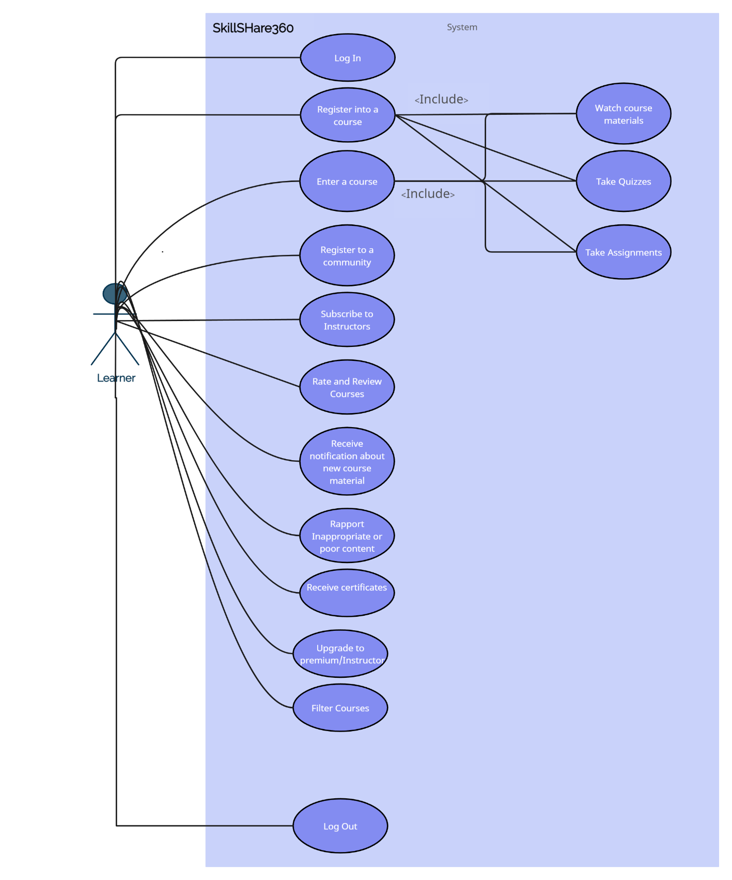

Use Case 2 Premium

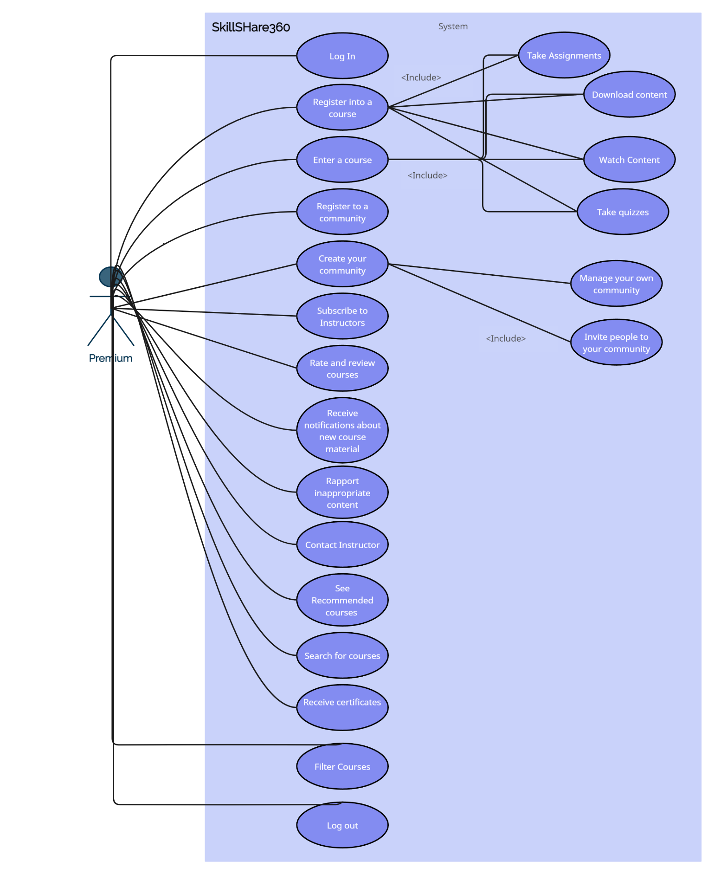

Use Case 3 Instructor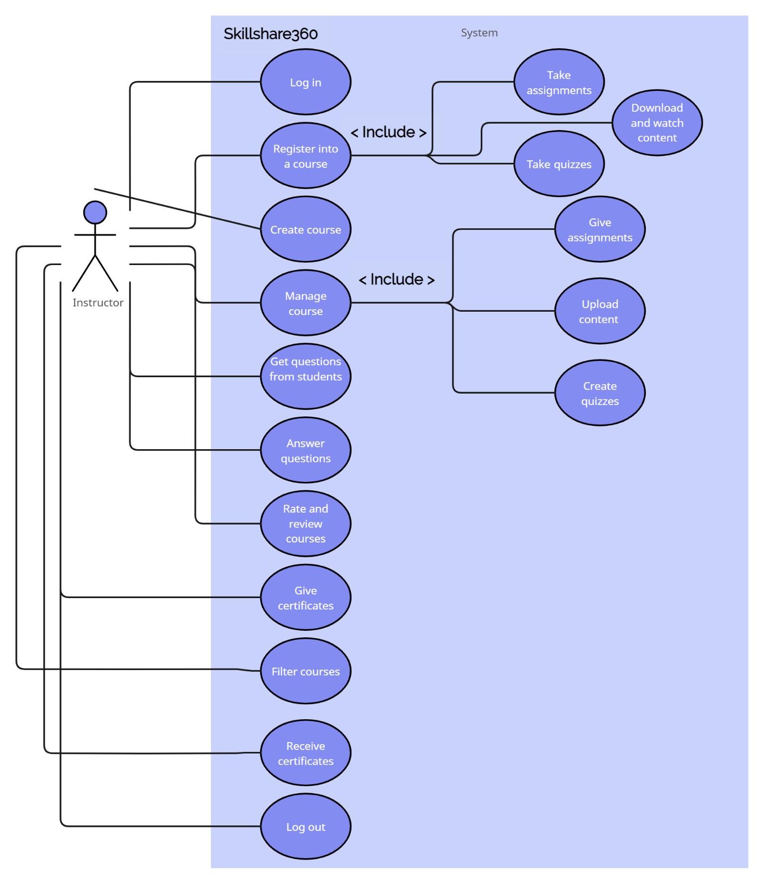

Use Case 4 General

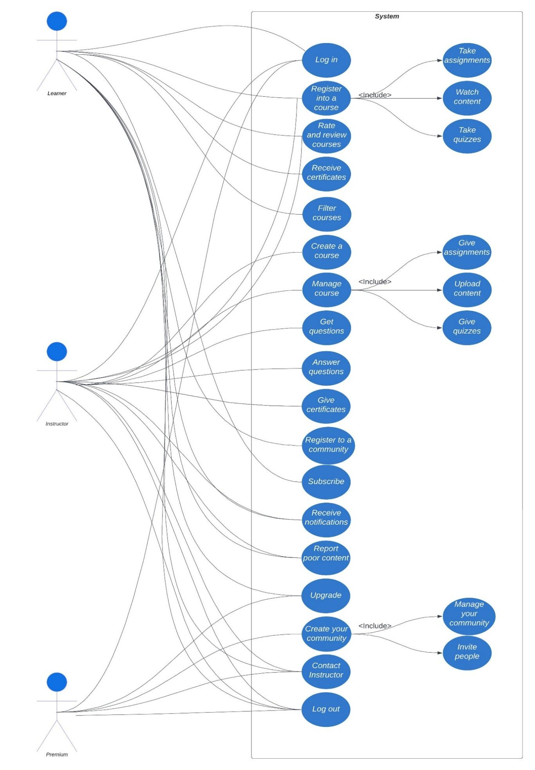

***4.7 Activity Diagrams***

#01 Log In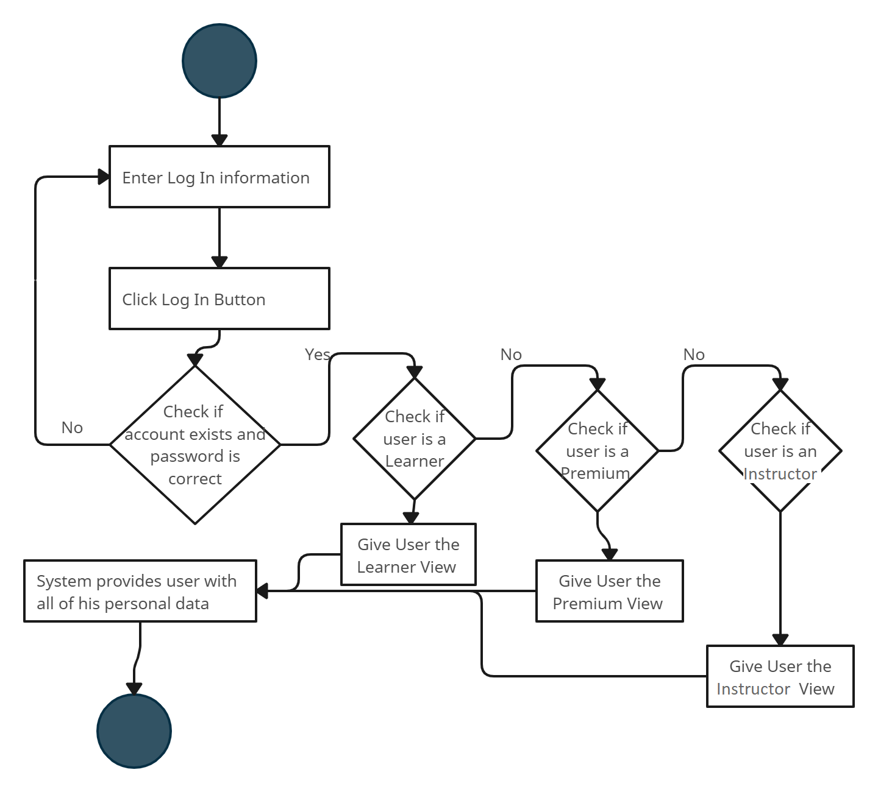

#02 Sign Up

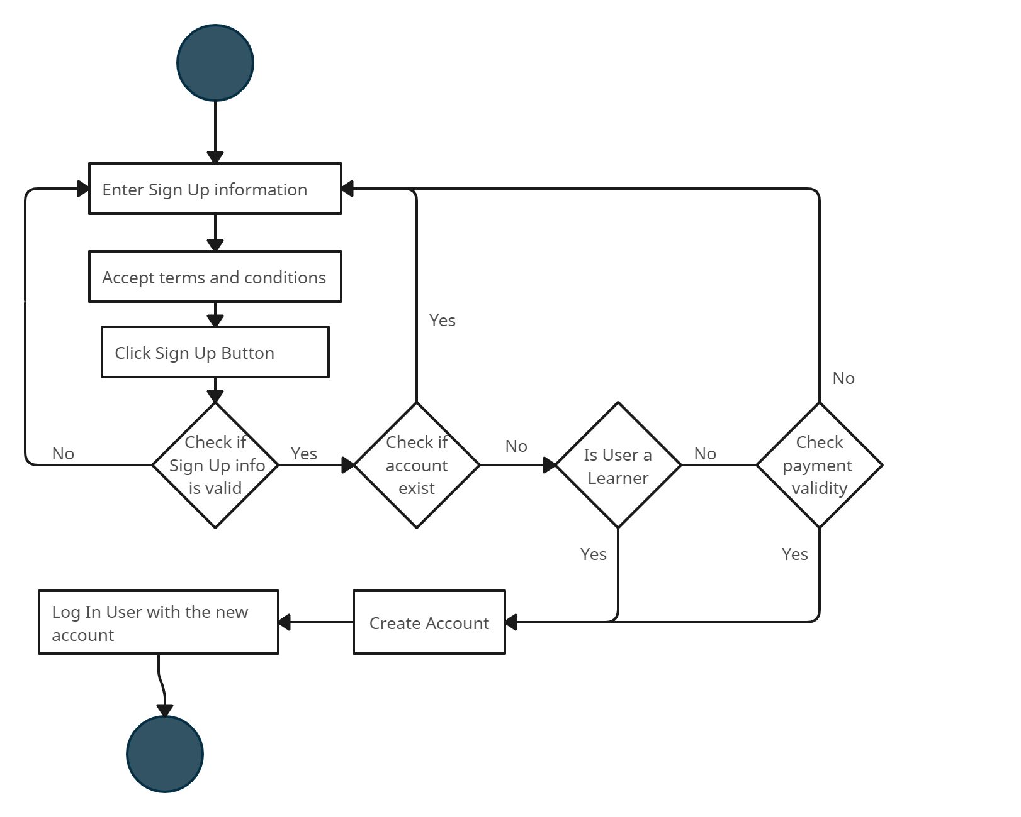

#03 Create Course

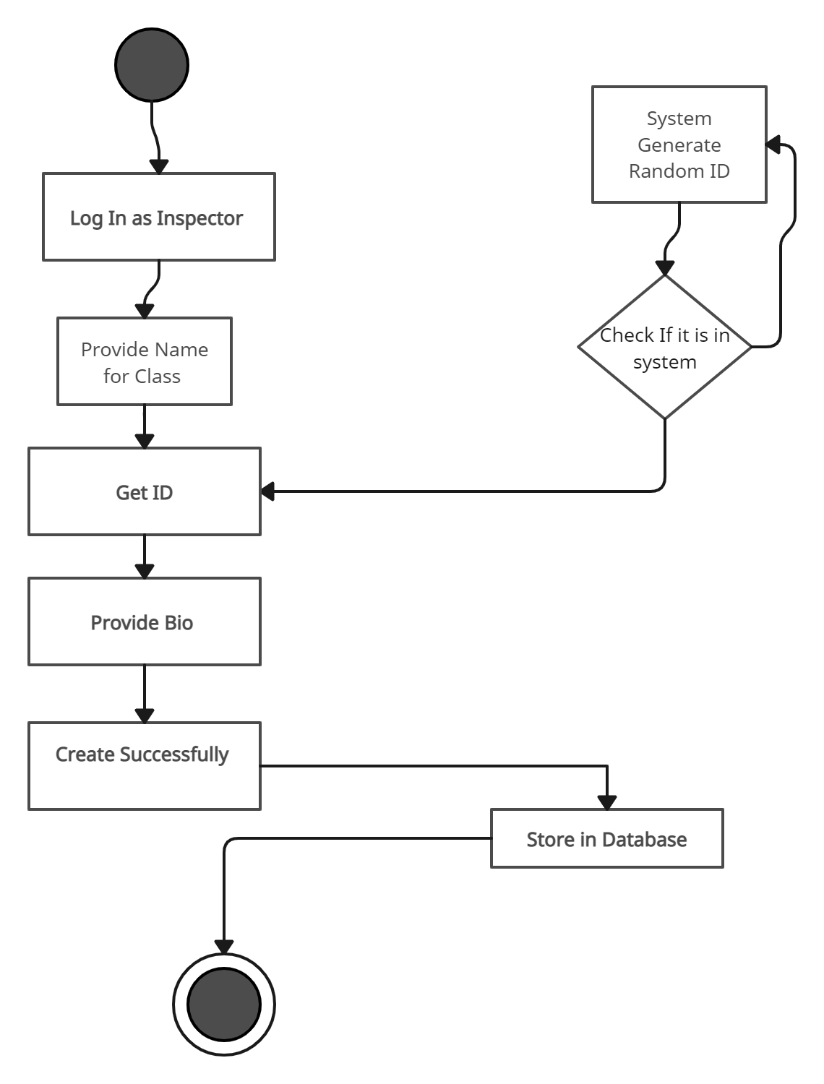

#04 Register Course

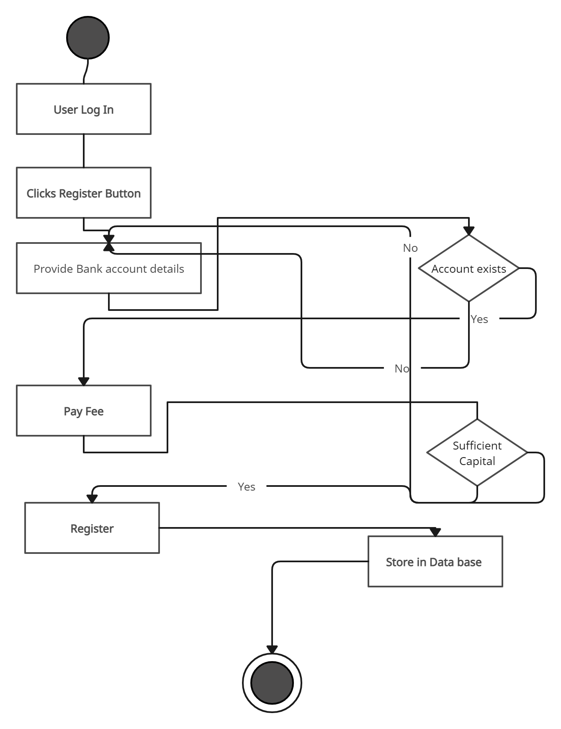

#05 Rate Course

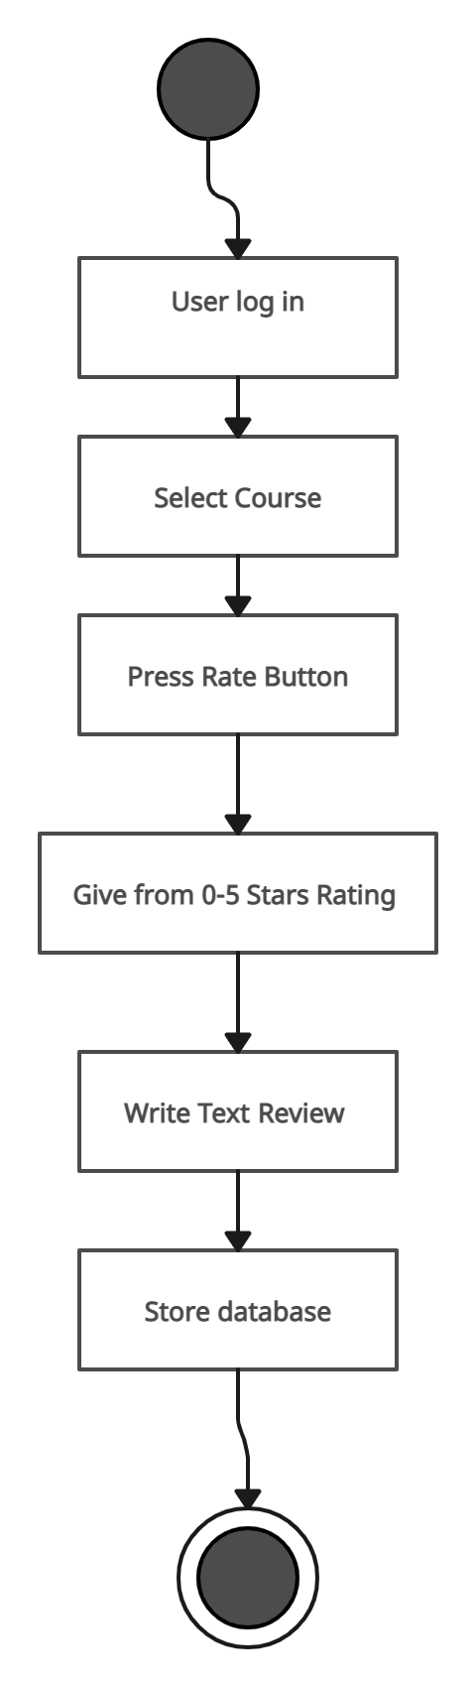

#06 Premium Creates Community

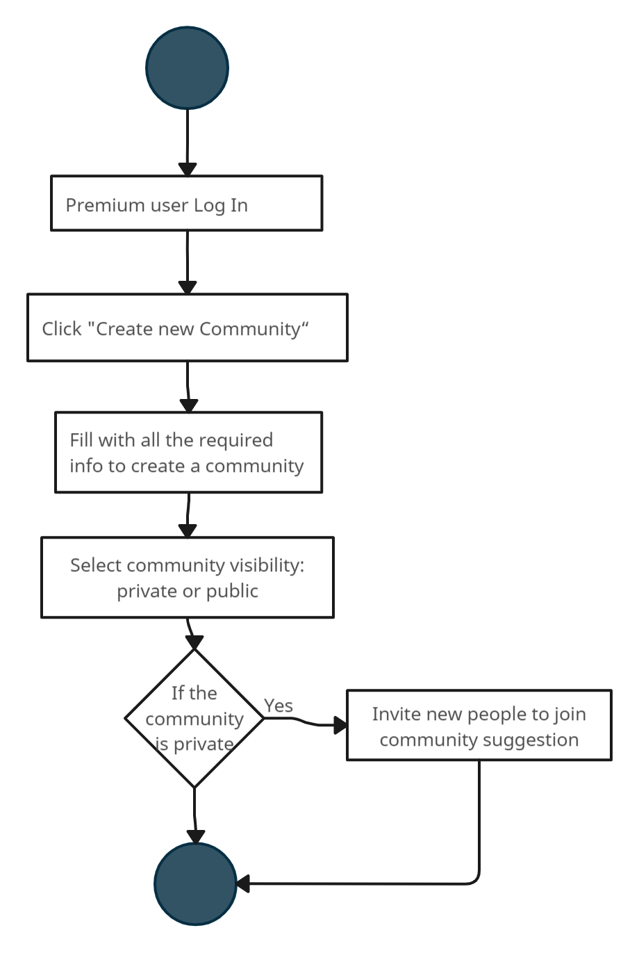

#07 User joins community

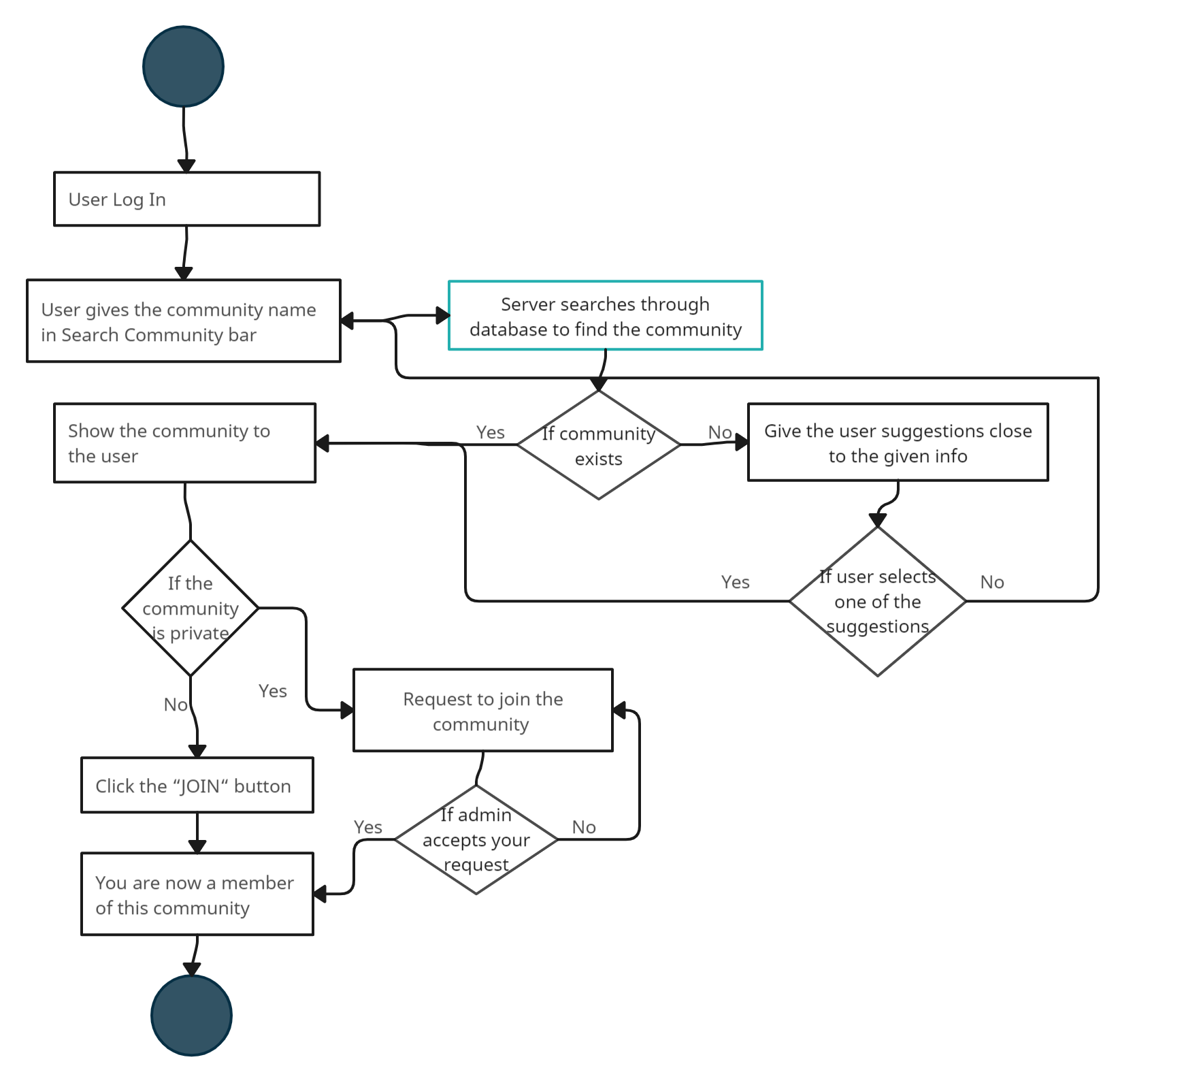

#08 Instructor adds materials

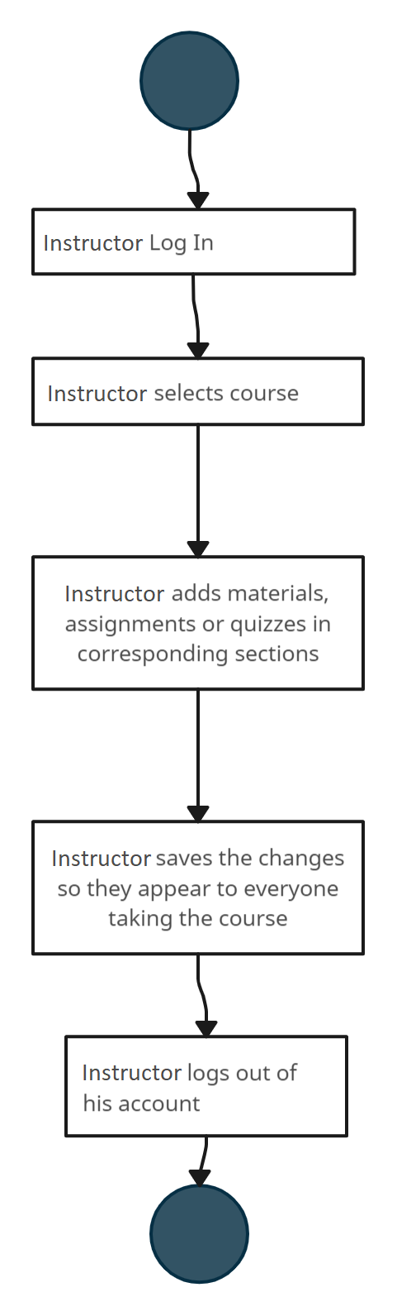

#09 Submit Question

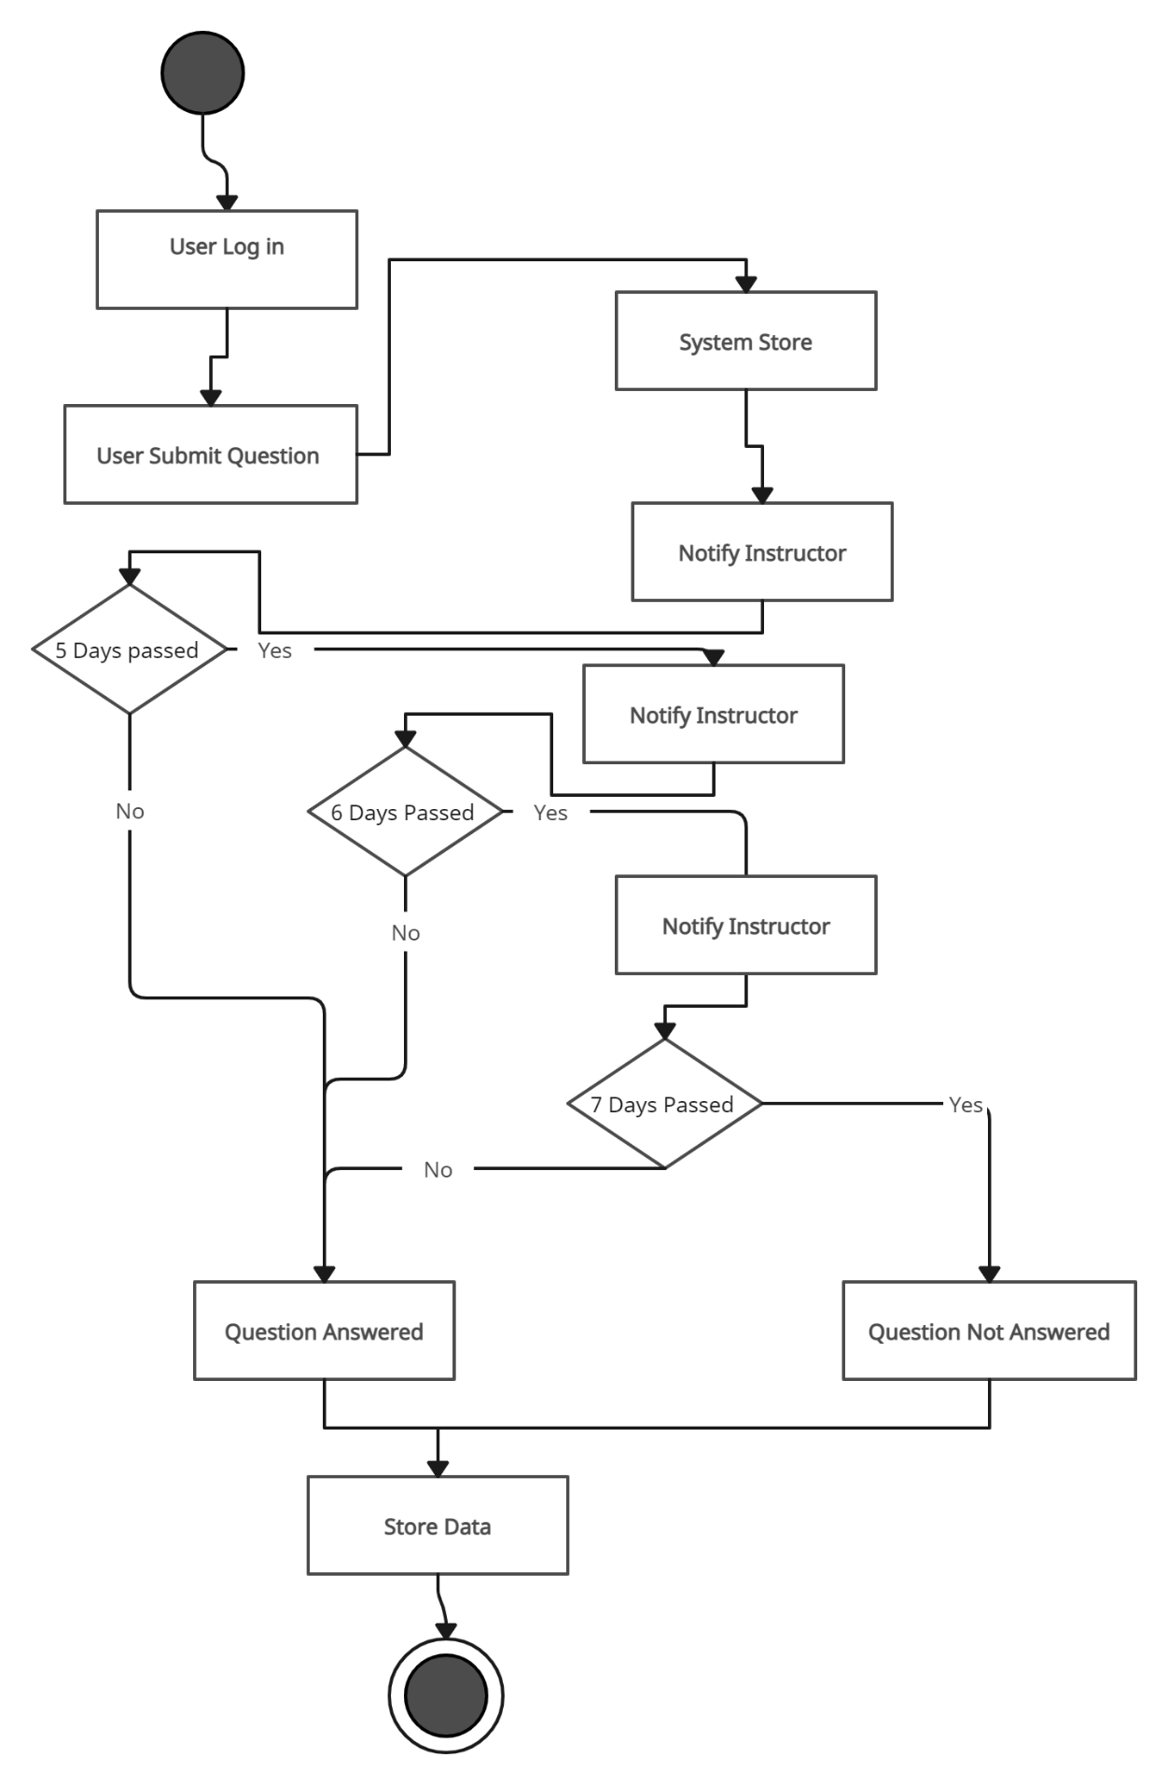

#10 User Takes Quiz

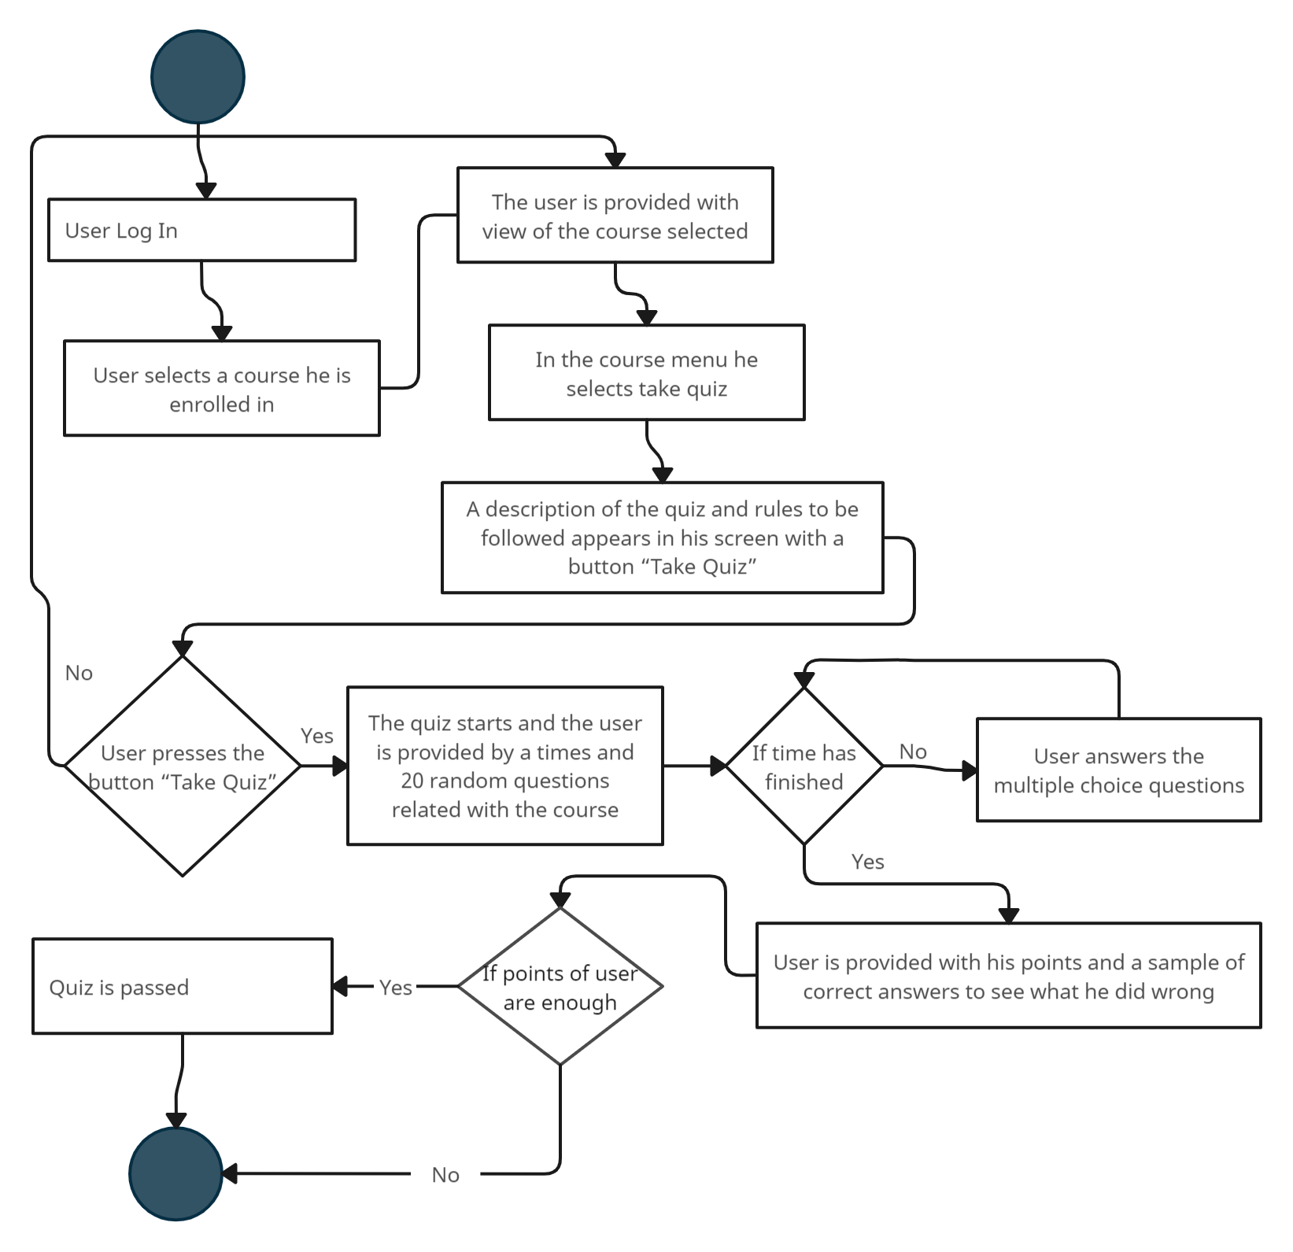

#11 Online Certificate

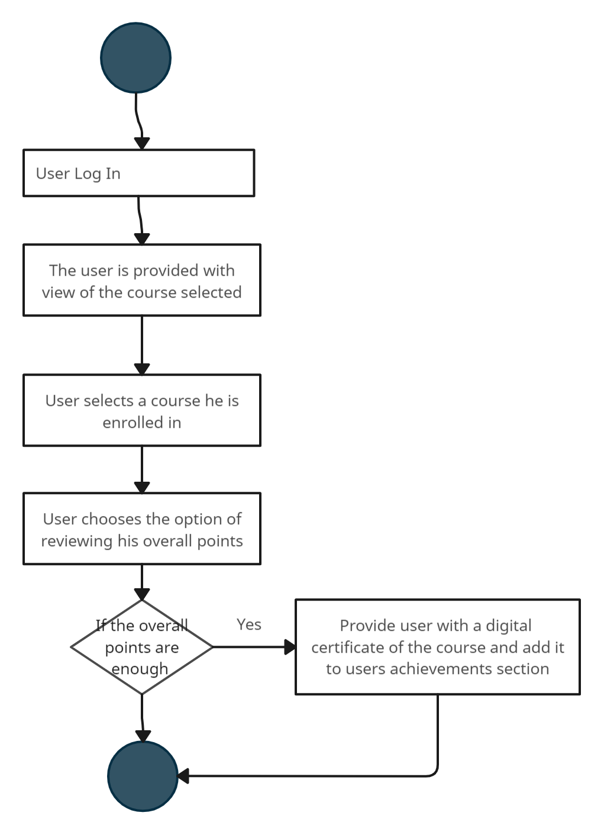

#13 Report Content

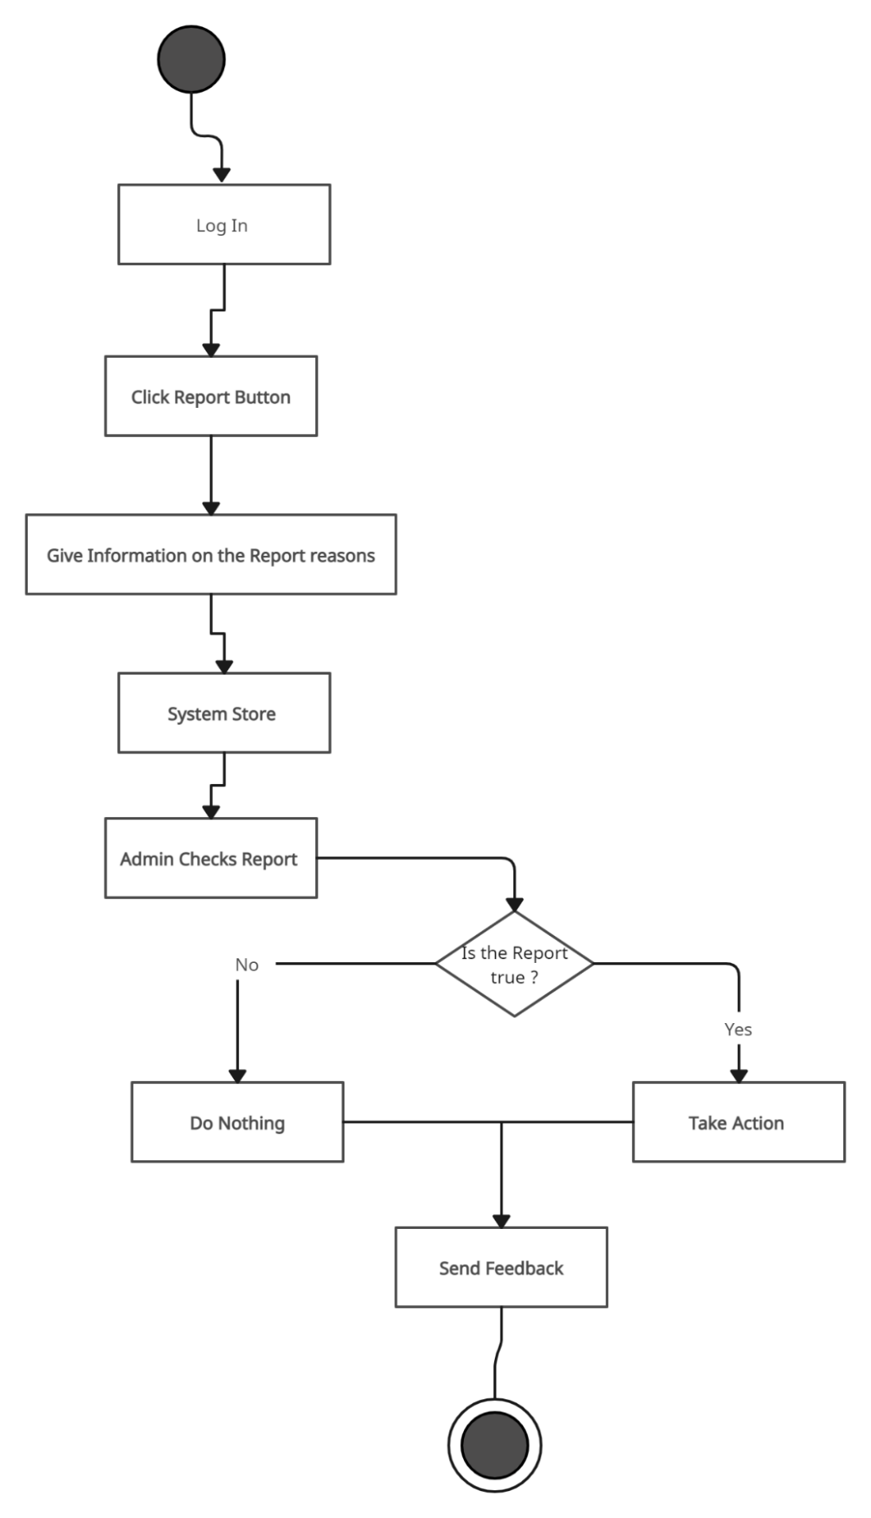

#14 Recommendation

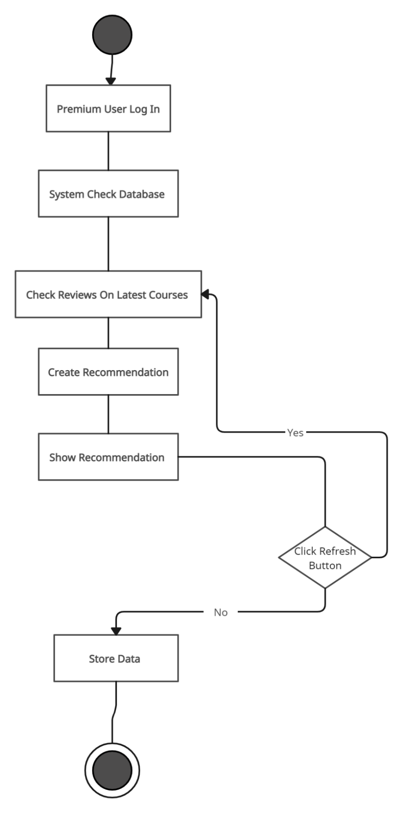

***4.9 State Diagrams***

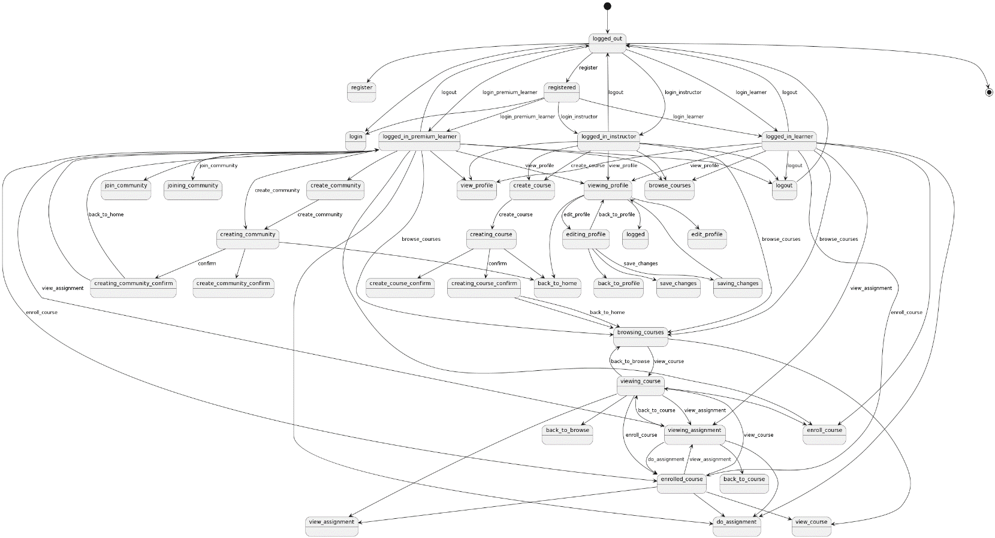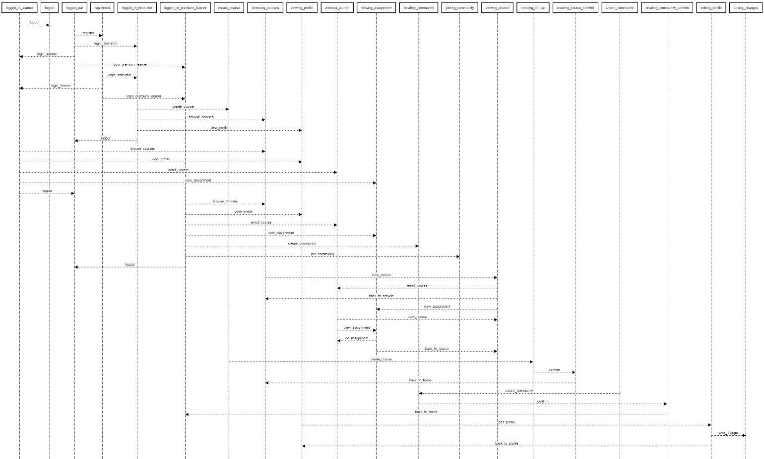

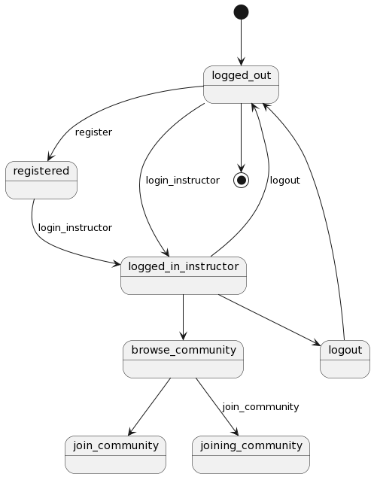

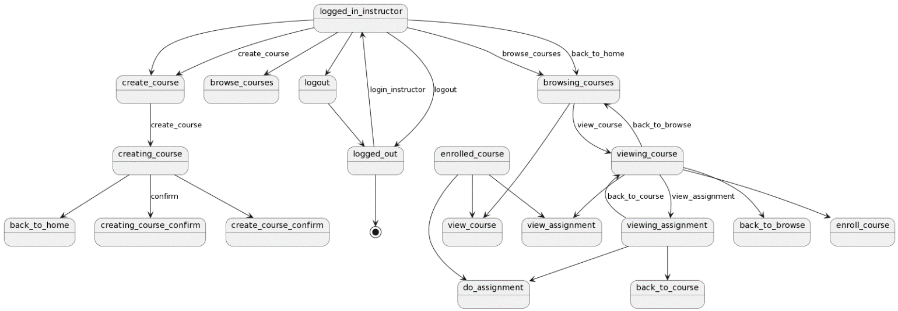

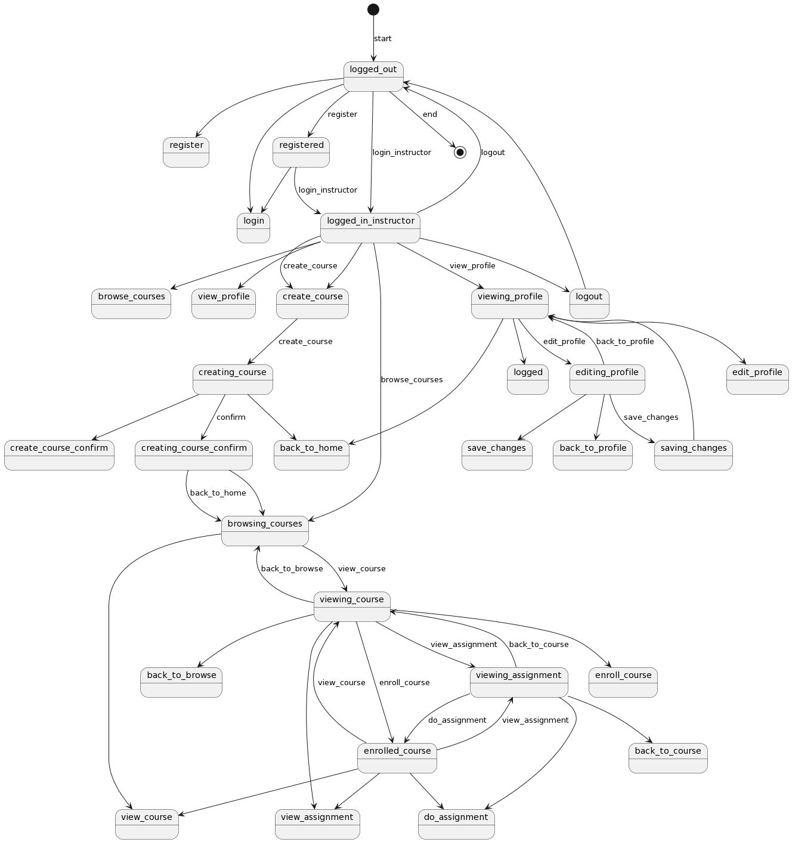

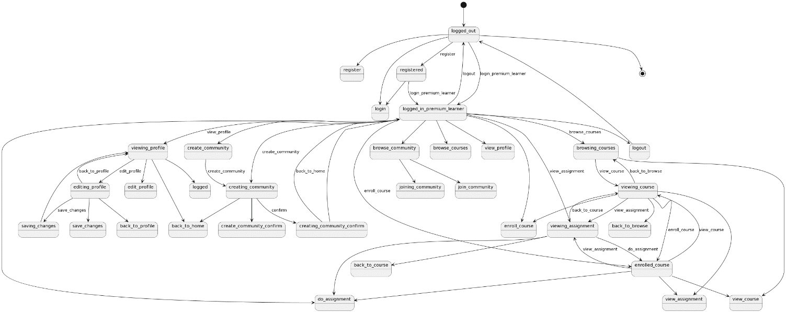

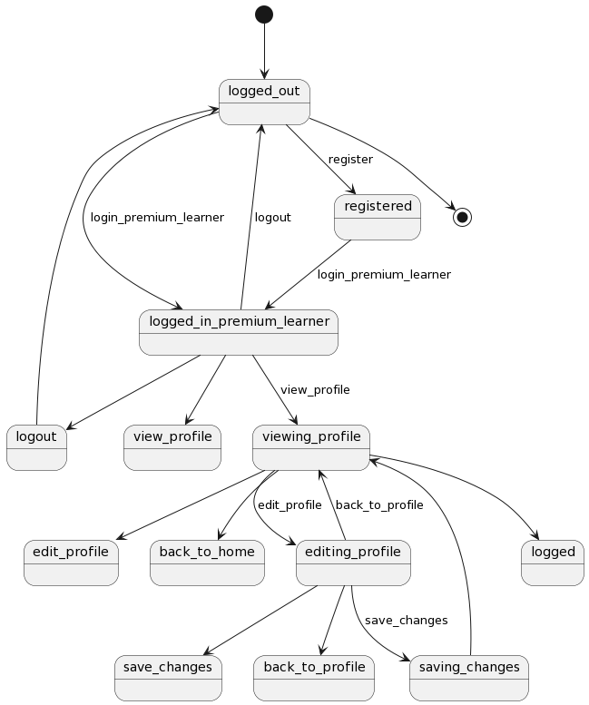

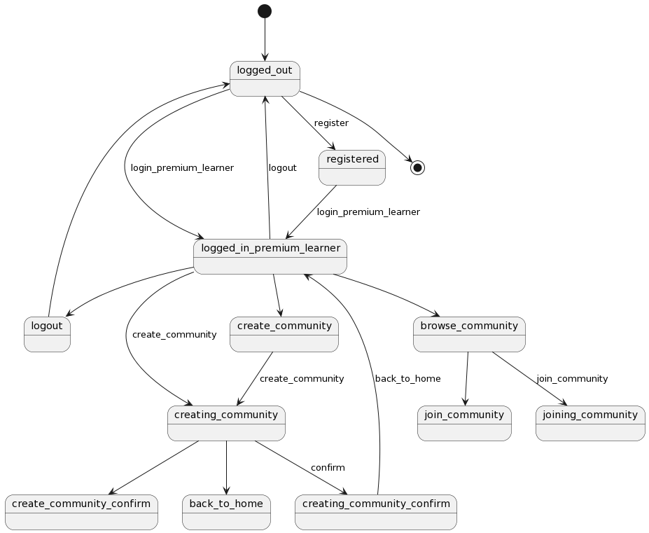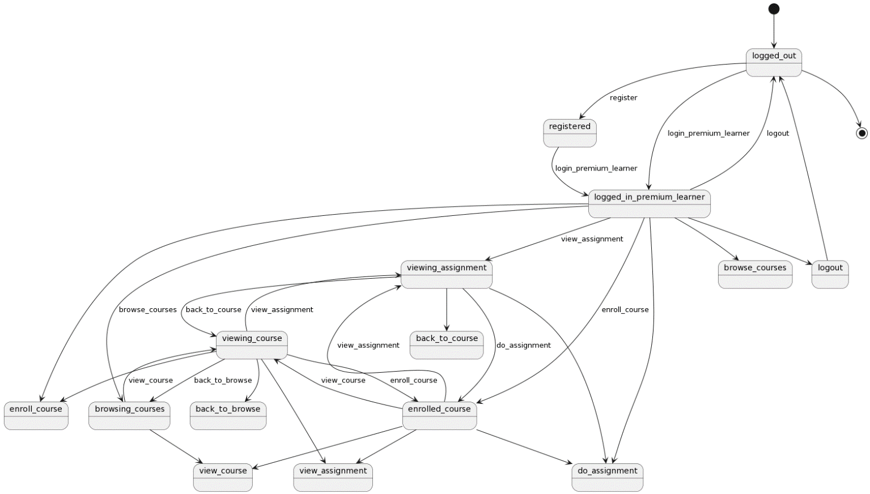

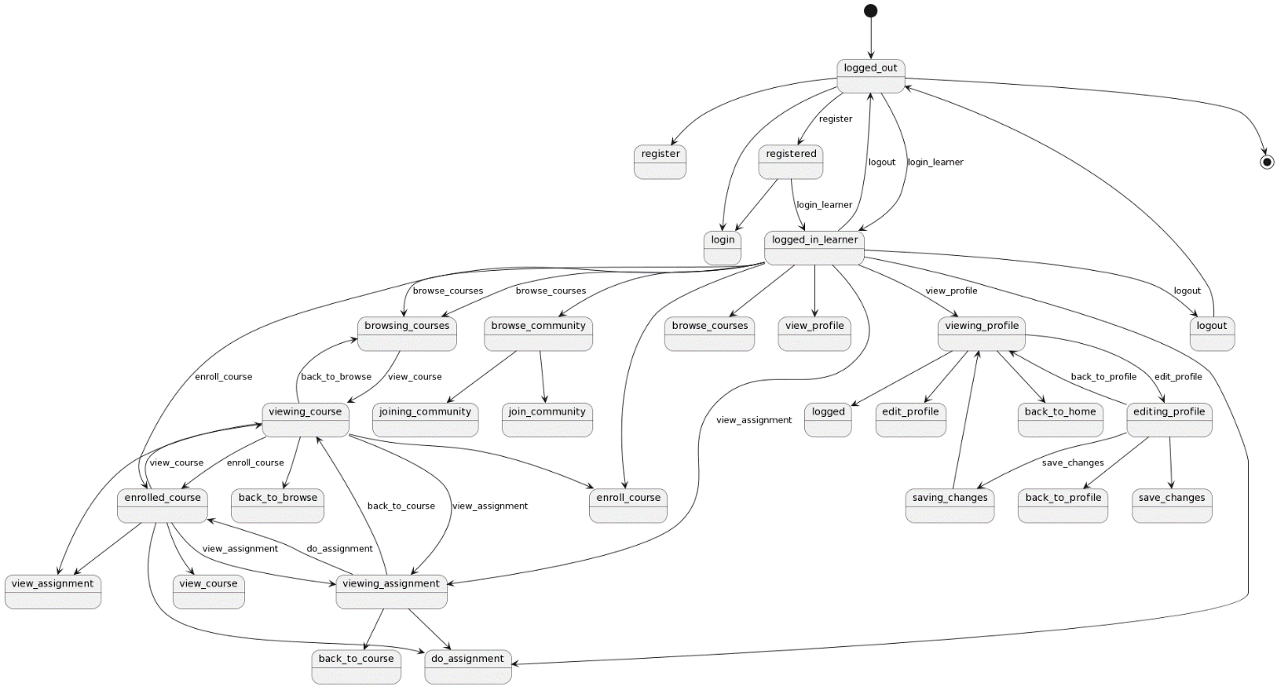

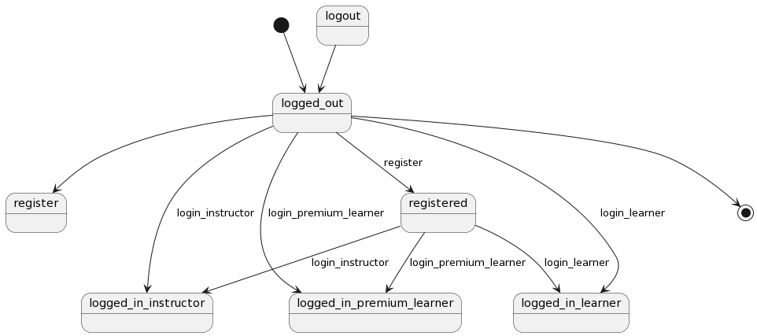

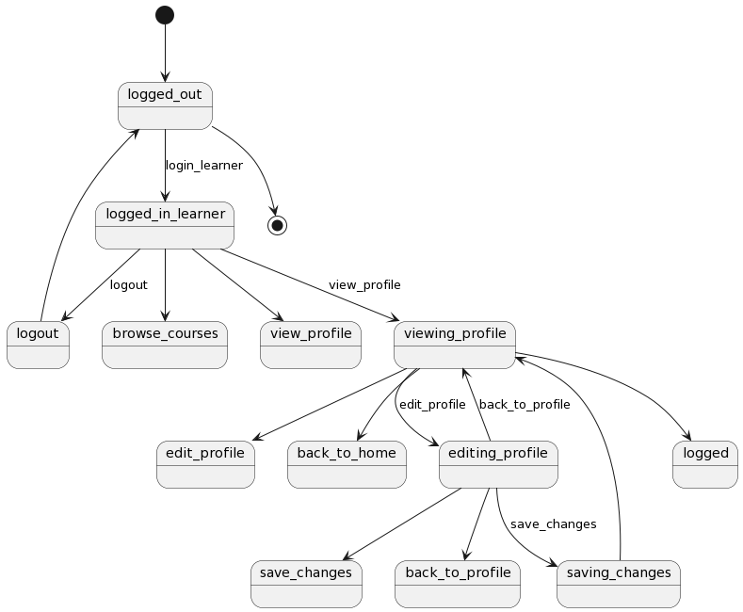

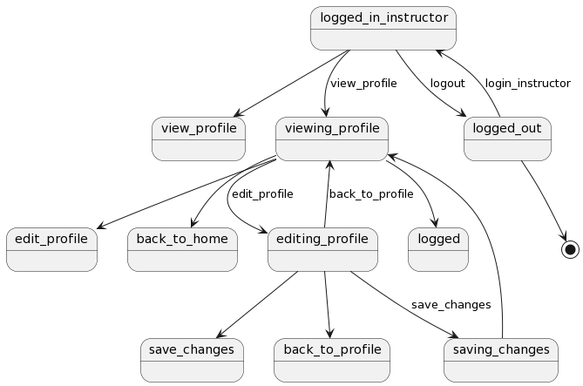

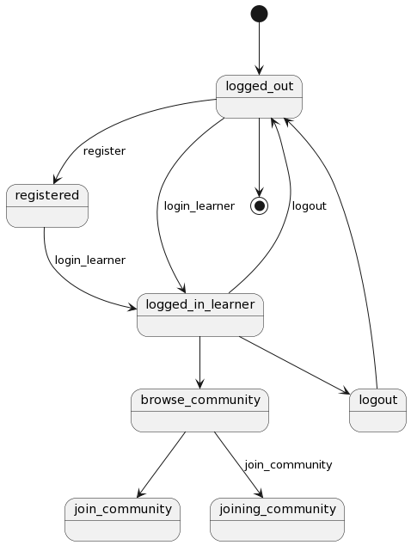

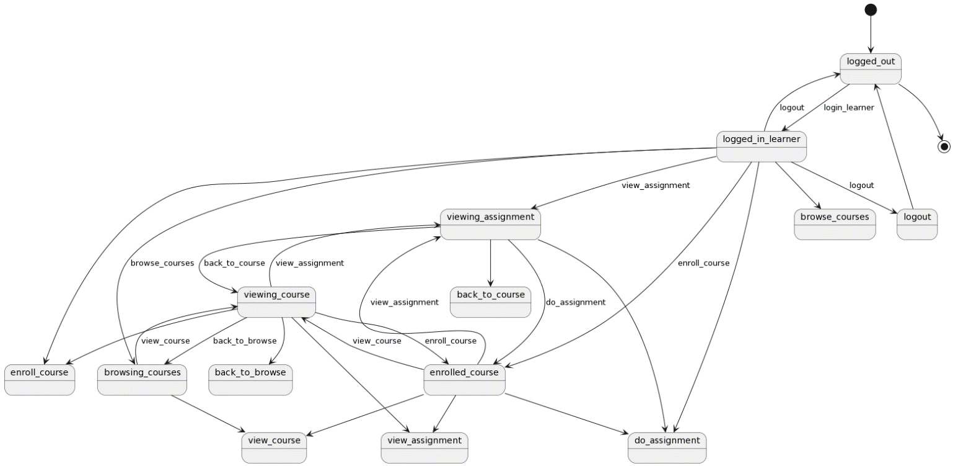

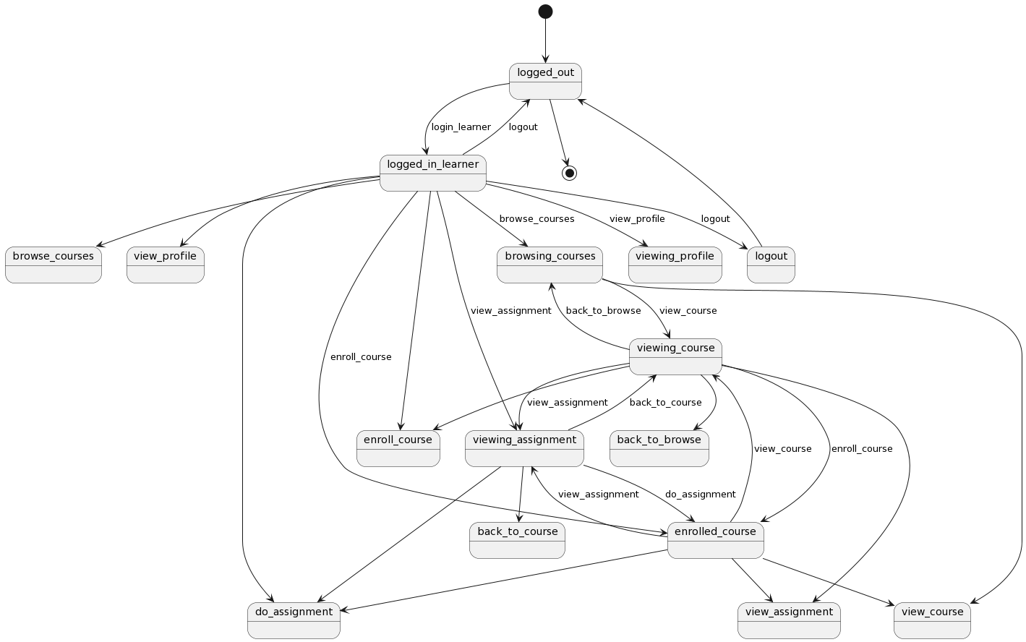

##### Sequence diagrams

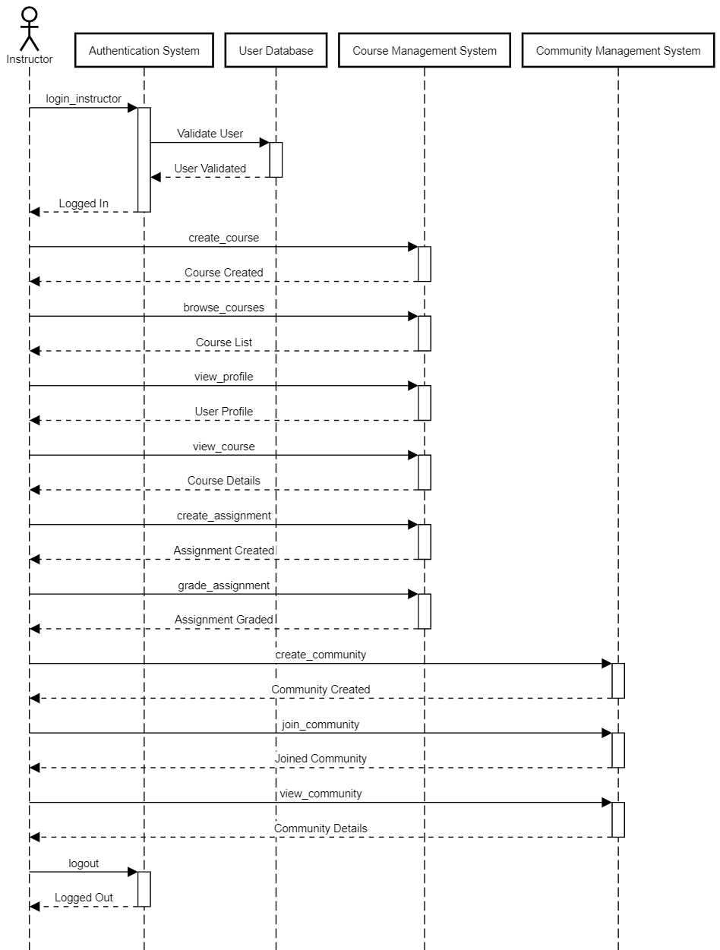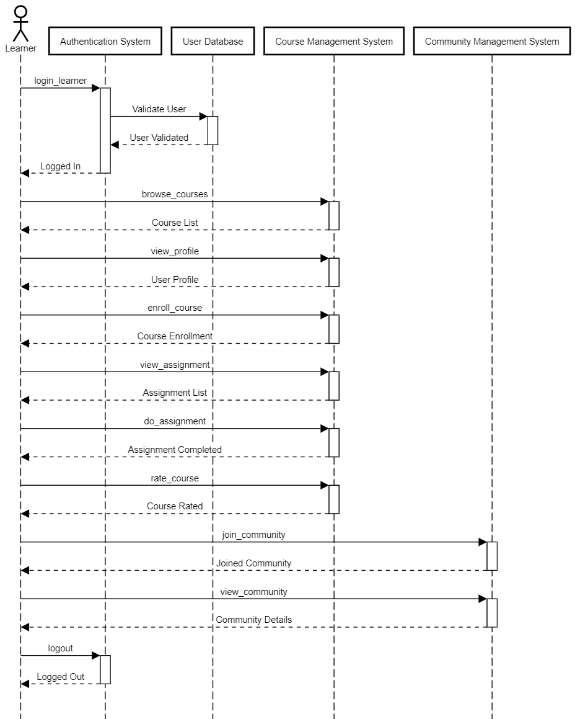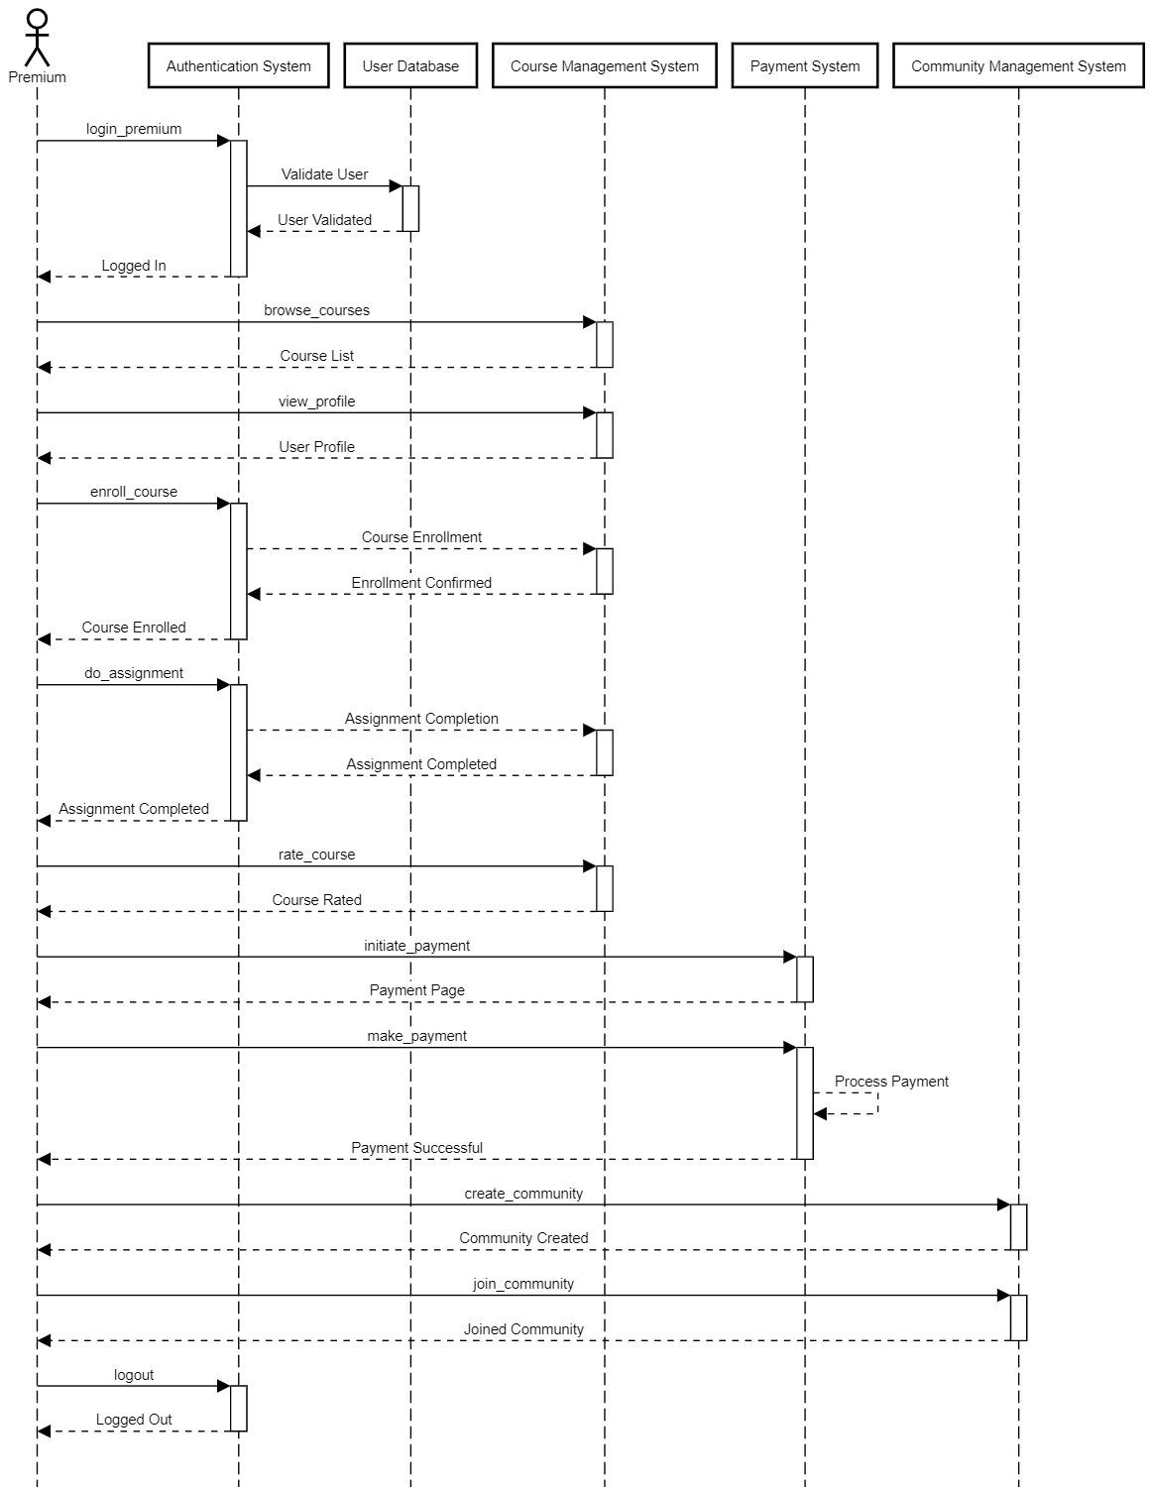

***4.12 Class Diagrams***

***General Class Diagram***

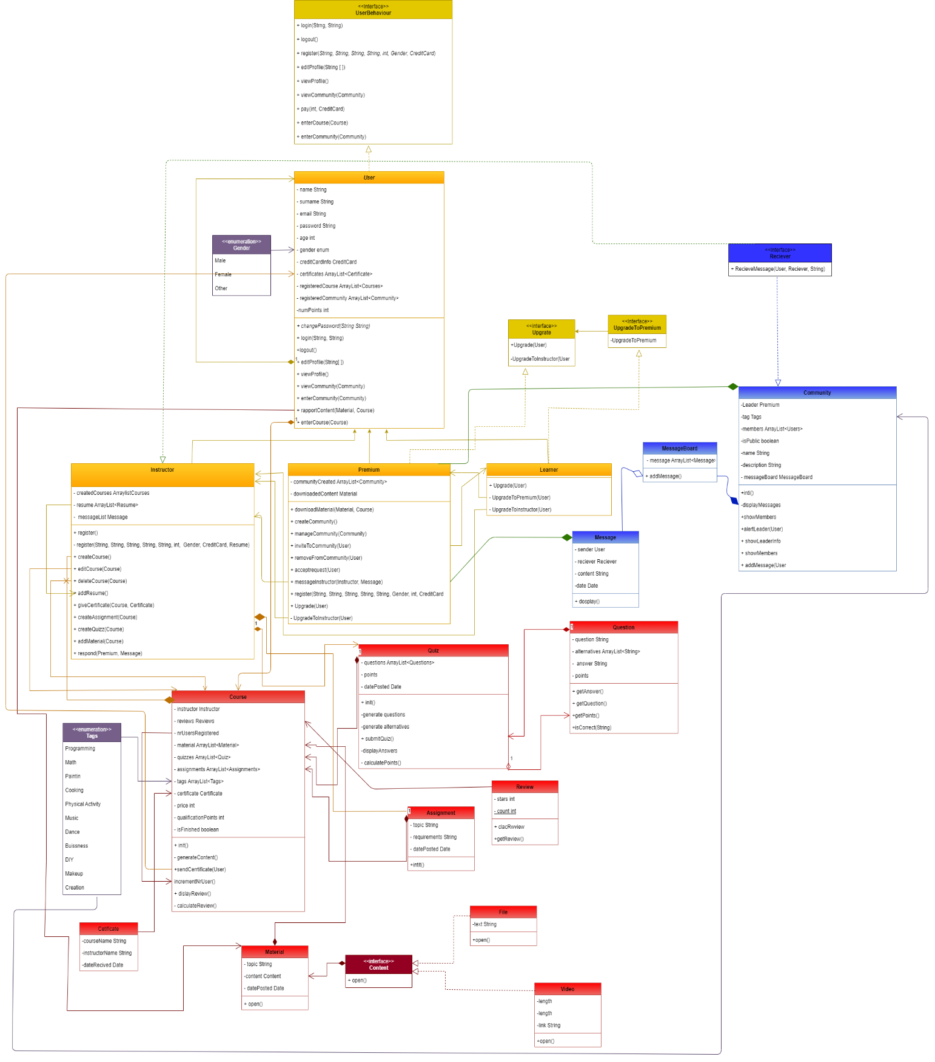

***User Class Diagram***

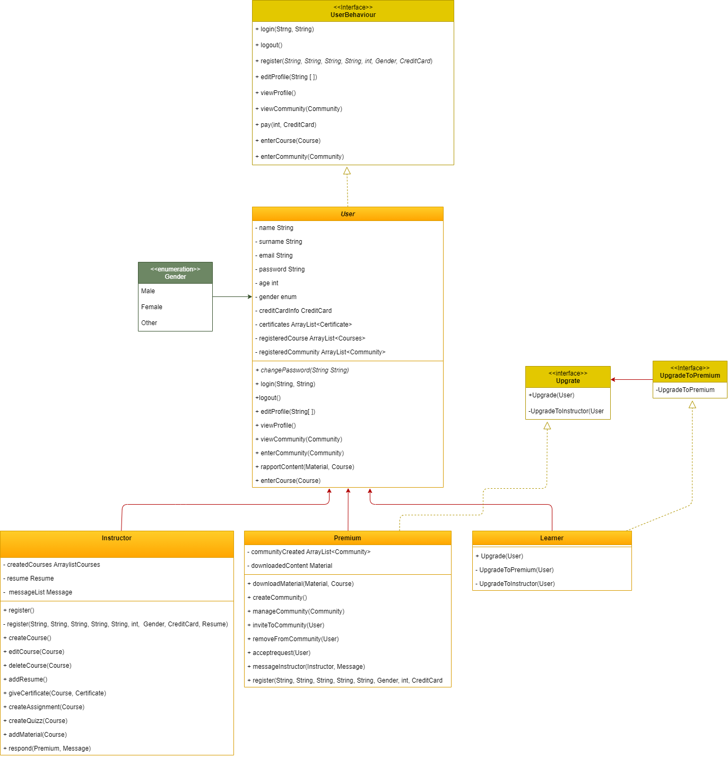

***Course Class Diagram***

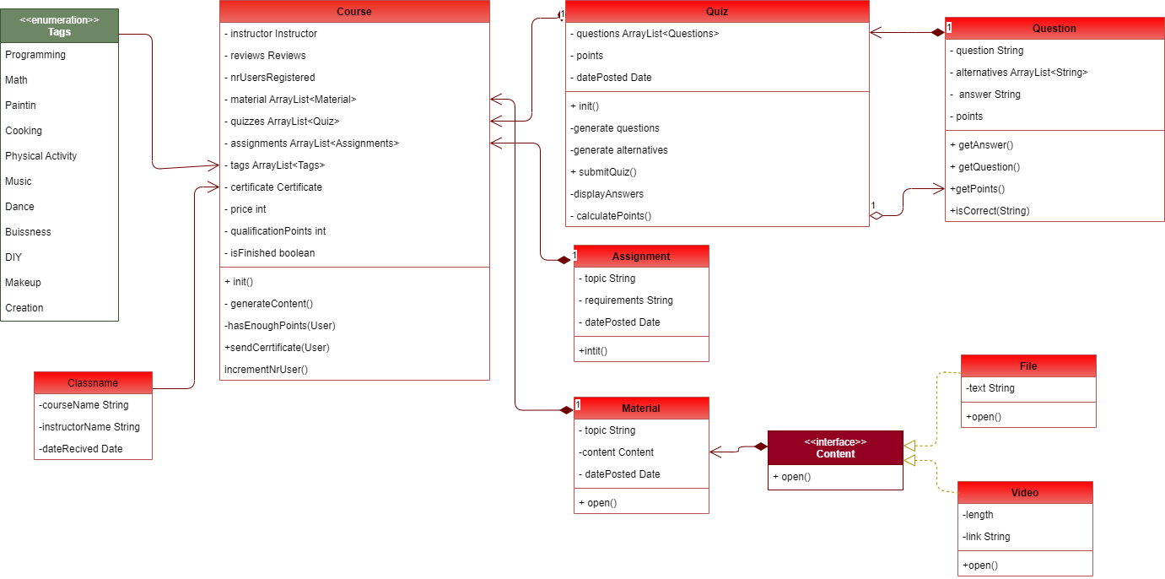

APPENDIX

The appendixes are not always considered part of the actual Requirements Specification and are not always necessary. They may include

* Sample input/output formats, descriptions of cost analysis studies, or results of user surveys;
* Supporting or background information that can help the readers of the Requirements Specification;
* A description of the problems to be solved by the system;
* Special packaging instructions for the code and the media to meet security, export, initial loading, or other requirements.

When appendixes are included, the Requirements Specification should explicitly state whether or not the appendixes are to be considered part of the requirements.

1. **Definitions, Acronyms, and Abbreviations**

Define all terms, acronyms, and abbreviations used in this document.

1. **References**

List all the documents and other materials referenced in this document.

1. **Requirements Traceability Matrix**

The following trace matrix examples show one possible use of naming standards for deliverables (FunctionalArea-DocType-NN). The number has no other meaning than to keep the documents unique. For example, the Bargaining Unit Assignment Process Flow would be BUA-PF-01.

For example (1):

| **Business Requirement** | **Area** | **Deliverables** | **Status** |
| --- | --- | --- | --- |
| BR_LR_01  The system should validate the relationship between Bargaining Unit/Location and Job Class.---Comments: Business Process = "Assigning a Bargaining Unit to an Appointment" (Priority 1) | BUA | BUA-CD-01  Assign BU Conceptual Design | Accepted |
| BUA-PF-01  Derive Bargaining Unit-Process Flow Diagram | Accepted |
| BUA-PF-01  Derive Bargaining Unit-Process Flow Diagram | Accepted |
| BR_LR_09  The system should provide the capability for the Labor Relations Office to maintain the job class/union relationship.---Comments: Business Process = "Maintenance" (Priority 1) | BUA | BUA-CD-01  Assign BU Conceptual Design | Accepted |
| BUA-PF-02  BU Assignment Rules Maint Process Flow Diagram | ReadyForReview |

For example (2):

| **BizReqID** | **Pri** | **Major Area** | **DevTstItems DelivID** | **Deliv Name** | **Status** |
| --- | --- | --- | --- | --- | --- |
| BR_LR_01 | 1 | BUA | BUA-CD-01 | Assign BU Conceptual Design | Accepted |
| BR_LR_01 | 1 | BUA | BUA-DS-02 | Bargaining Unit Assignment DB Modification Description | Accepted |
| BR_LR_01 | 1 | BUA | BUA-PF-01 | Derive Bargaining Unit-Process Flow Diagram | Accepted |
| BR_LR_01 | 1 | BUA | BUA-UCD-01 | BU Assign LR UseCase Diagram | ReadyForReview |
| BR_LR_01 | 1 | BUA | BUA-UCT-001 | BU Assignment by PC UseCase - Add Appointment and Derive UBU | Reviewed |
| BR_LR_01 | 1 | BUA | BUA-UCT-002 | BU Assignment by PC UseCase - Add Appointment (UBU Not Found) | Reviewed |
| BR_LR_01 | 1 | BUA | BUA-UCT-006 | BU Assignment by PC UseCase - Modify Appointment (Removed UBU) | Reviewed |
| BR_LR_09 | 1 | BUA | BUA-CD-01 | Assign BU Conceptual Design | Accepted |
| BR_LR_09 | 1 | BUA | BUA-DS-02 | Bargaining Unit Assignment DB Modification Description | Accepted |
| BR_LR_09 | 1 | BUA | BUA-PF-02 | BU Assignment Rules Maint Process Flow Diagram | Accepted |
| BR_LR_09 | 1 | BUA | BUA-UCD-03 | BU Assign Rules Maint UseCase Diagram | Reviewed |
| BR_LR_09 | 1 | BUA | BUA-UCT-045 | BU Assignment Rules Maint: Successfully Add New Assignment Rule | Reviewed |
| BR_LR_09 | 1 | BUA | BUA-UCT-051 | BU Assignment Rules MaintUseCase: Modify Rule | Reviewed |
| BR_LR_09 | 1 | BUA | BUA-UCT-053 | BU Assignment Rules MaintUseCase - Review Assignment Rules | Reviewed |
| BR_LR_09 | 1 | BUA | BUA-UCT-057 | BU Assignment Rules MaintUseCase: Inactivate Last Rule for a BU | Reviewed |
| BR_LR_09 | 1 | BUA | BUA-UI-02 | BU AssignRules Maint UI Mockups | ReadyForReview |
| BR_LR_09 | 1 | BUA | BUA-TC-021 | BU Assignment Rules Maint TestCase: Add New Rule (Associated Job Class Does Not Exist) - Success | ReadyForReview |
| BR_LR_09 | 1 | BUA | BUA-TC-027 | BU Assignment Rules Maint TestCase: Modify Rule - Success | ReadyForReview |
| BR_LR_09 | 1 | BUA | BUA-TC-035 | BU Assignment Rules Maint TestCase: Add New Rule (Associated Job Class Does Not Exist) - Error Condition | ReadyForReview |
| BR_LR_09 | 1 | BUA | BUA-TC-049 | BU Assignment Rules Maint TestCase: Modify Rule - Error Condition | ReadyForReview |

For example (3):

| **BizReqID** | **CD01** | **CD02** | **CD03** | **CD04** | **UI01** | **UI02** | **UCT01** | **UCT02** | **UCT03** | **TC01** | **TC02** | **TC03** | **TC04** |
| --- | --- | --- | --- | --- | --- | --- | --- | --- | --- | --- | --- | --- | --- |
| BR_LR_01 |  |  | X |  | X |  | X |  |  | X |  | X |  |
| BR_LR_09 | X |  |  | X |  | X |  |  | X |  | X |  | X |
| BR_LR_10 | X |  |  | X |  |  |  |  | X |  | X |  |  |
| BR_LR_11 |  | X |  |  |  |  |  |  |  |  |  |  |  |

1. **Organizing the Requirements**

This section is for information only as an aid in preparing the requirements document.

Detailed requirements tend to be extensive. Give careful consideration to your organization scheme. Some examples of organization schemes are described below:

**By System Mode**

Some systems behave quite differently depending on the mode of operation. For example, a control system may have different sets of functions depending on its mode: training, normal, or emergency.

**By User Class**

Some systems provide different sets of functions to different classes of users. For example, an elevator control system presents different capabilities to passengers, maintenance workers, and fire fighters.

**By Objects**

Objects are real-world entities that have a counterpart within the system. For example, in a patient monitoring system, objects include patients, sensors, nurses, rooms, physicians, medicines, etc. Associated with each object is a set of attributes (of that object) and functions (performed by that object). These functions are also called services, methods, or processes. Note that sets of objects may share attributes and services. These are grouped together as classes.

**By Feature**

A feature is an externally desired service by the system that may require a sequence of inputs to affect the desired result. For example, in a telephone system, features include local call, call forwarding, and conference call. Each feature is generally described in a sequence of stimulus-response pairs, and may include validity checks on inputs, exact sequencing of operations, responses to abnormal situations, including error handling and recovery, effects of parameters, relationships of inputs to outputs, including input/output sequences and formulas for input to output.

**By Stimulus**

Some systems can be best organized by describing their functions in terms of stimuli. For example, the functions of an automatic aircraft landing system may be organized into sections for loss of power, wind shear, sudden change in roll, vertical velocity excessive, etc.

**By Response**

Some systems can be best organized by describing all the functions in support of the generation of a response. For example, the functions of a personnel system may be organized into sections corresponding to all functions associated with generating paychecks, all functions associated with generating a current list of employees, etc.

**By Functional Hierarchy**

When none of the above organizational schemes prove helpful, the overall functionality can be organized into a hierarchy of functions organized by common inputs, common outputs, or common internal data access. Data flow diagrams and data dictionaries can be used to show the relationships between and among the functions and data.

**Additional Comments**

Whenever a new Requirements Specification is contemplated, more than one of the organizational techniques given above may be appropriate. In such cases, organize the specific requirements for multiple hierarchies tailored to the specific needs of the system under specification.

There are many notations, methods, and automated support tools available to aid in the documentation of requirements. For the most part, their usefulness is a function of organization. For example, when organizing by mode, finite state machines or state charts may prove helpful; when organizing by object, object-oriented analysis may prove helpful; when organizing by feature, stimulus-response sequences may prove helpful; and when organizing by functional hierarchy, data flow diagrams and data dictionaries may prove helpful.